“Could Stock Option Have Predicted the Current Market Tumble?”

-- A study of Options-Based Market Sentiment Indicators

Written by: John Smith
G492
March 29, 2009
smith@indiana.edu

Abstract:
This paper will examine the significance of option-based market sentiment indicators upon the derivatives markets as predicative tools. Essentially, this paper will study how technical and sentiment tools of analysis use price charts, put-call ratios, and volatility based indicators to gauge market trend. Further, it will analyze the validity of these tools as predicative measures of investor sentiment through utilizing the data from the CBOE. Finally, the paper will conclude its quantitative analysis by answering the question: “Could stock options have predicted the markets tumble?”, and if yes, “What do stock options have to say about the rest of this fiscal year?”

U.K. Healthcare Industry
The National Health Service, or NHS, is the United Kingdom’s government run healthcare system. Established after World War II, the NHS was created with three core principles in mind: to meet everybody’s needs , to be free at the point of delivery, and to be based on clinical need. The NHS is funded almost exclusively through national taxation, but receives a small amount of revenue from user fees for services such as dental care and prescription drugs.
The structure of the NHS has changed over the years, but it now is based on a system of trusts to which the Department of Health allocates funds based on demographic information. The trustscover different sectors of health care. Primary care trusts control 80% of the NHS budget and are responsible for front-line services such as doctors, dentists, opticians, pharmacists, and walk-in centers. Acute trusts run hospitals which may provide care for customers in several different primary trust catchment areas, and smaller trusts such as ambulance and mental health trusts manage things such as ambulances for 911 calls and specialized long-term mental health care.
The NHS employed over 1.5 million people in the United Kingdom as of 2008. Half of them are medical professionals such as doctors, nurses, and paramedics, while the other half is non-clinical support staff. These health professionals deal with about 240 million visits each year, at a cost of about $90 billion, having grown at an annual rate of 3% above inflation since 1948. 60% of the NHS budget goes to paying staff, 20% goes to drugs and supplies, and the final 20% to buildings, equipment, and other expenses. The NHS budget in 2008 represented around $1,500 for each UK resident.

Brief History of Hedge Fund
The first hedge fund was formed by Alfred W. Jones in 1949 (McWhinney). Jones used short selling to hedge against market risk, pioneering the now well-known long/short equity strategy. Jones also utilized leverage in his fund to increase returns. The industry stayed relatively small over the next 15 to 20 years until a 1966 Fortune article authored by none other than Jones himself highlighted the huge returns of his and other funds (McWhinney). Over the next five years scores of hedge funds sprang up, many employing riskier strategies than Jones’. The bear market of ’73-’74 killed many funds, and the industry was fairly quiet until the late ‘80’s (McWhinney).
In 1986 an Institutional Investor article detailing the tremendous performance of Julian Robertson’s Tiger Fund once again placed hedge funds in the spotlight (McWhinney). Throughout the 1990’s a number of mutual fund managers moved to hedge funds, lured by the higher management fees. In the early 2000’s total assets under management of hedge funds grew dramatically as institutional investors such as pension funds began taking larger positions (Herbst-Bayless). Though central statistics don’t exist, it is believed that the hedge fund industry managed anywhere between two and three trillion dollars in assets by 2008 (McWhinney). Even in the midst of the economic crisis there still exists a high level of interest in hedge fund investment, and the industry, as yet, has faired surprisingly well given the current market conditions.

My thought would be that college students would do more of their shopping online than adults because Generation Y essentially grew up on the Internet, and they are extremely tech-savvy. However, my survey results show differently:
“During the past holiday season what percent of your overall gift buying came from the following channels?”
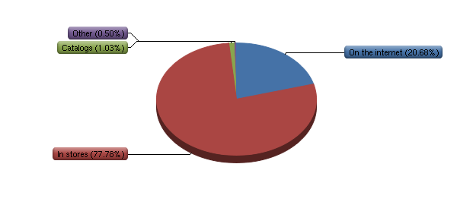

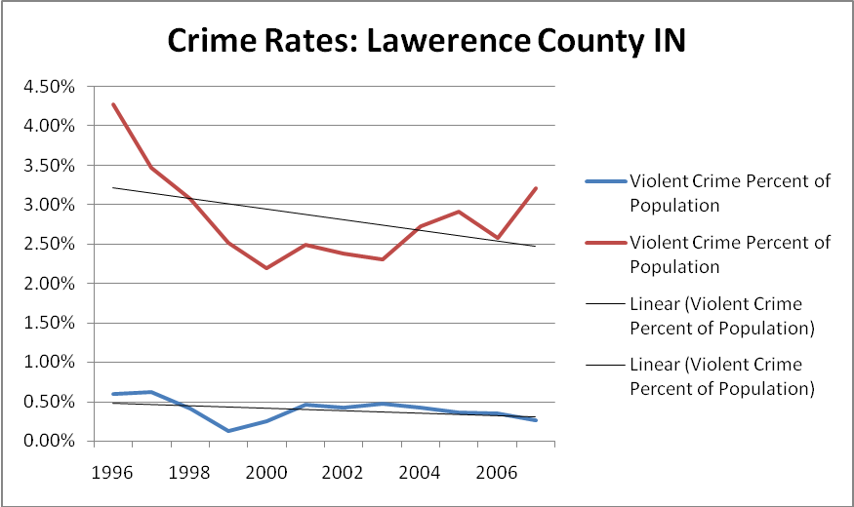

Australia spends far less on health care than the U.S. in both absolute and per capita terms. National spending per capita in Australia is $3,128 compared to $6,697 in the United States (C). In recent years, U.S. spending on health care has exceeded double the average of all other OECD countries (Y). This is the result of increases in spending exceeding the rest of the economy since the 1960s (B). In 1970, medical expenses accounted for less than one-tenth of personal consumption in the U.S. making it the fifth largest component. In 2001, medical expenses were the largest section of personal consumption accounting for 18.2% of the total (A). Regardless of attempts made by the government to control the increase of health expenses, they have risen much quicker than inflation over the last few decades (B). Australia has maintained control of its health care expenses and projects increases only in absolute terms over the next few years (M), meaning it will remain around 9% of GDP while the U.S. has already reached 16% of GDP.

References Cited

Basham, Patrick and Karen White. "Gambling with Our Future." 01 Feb 2002 3-150. 01 MAR 2009

Eadington, William. "Contributions of Casino Gambling Style Gambling to Local Economies." 28 Mar 2009 <http://www.rochesterdowntown.org/news/rddc_casino/GENERALINFO/gen15.pdf.>.

Eadington, William. "The Legalization of Casinos: Policy Objectives, Regulatory Alternatives, and Cost Benefit Considerations." Journal of Travel Research 34; 3(1996): 3-8.

Earl, Grinois. "Casino Gambling Causes Crime." Policy Forum. 02 NOV 2000. University of Illinois. 16 Feb 2009 <http://www.thefactsaboutindiangaming.com/FILES/03_Facts/_2000-UofIllinois-casinocausescrimes.pdf>.

Henriksson, Lennart and Richard Lipsey. "Should Provinces Expand Gambling." 01 JAN 1999 259-271. 03 Mar 2009 .

Hurst, Blake, Valerie Lorenz, Legalized Gambling. San Diego, CA: Greenhaven Press, Inc, 1999.

Kearny, Melissa. "The economic winners and losers of legalized gambling." Entrepreneur.com. 01 Jun 2005. 21 FEB 2009 <http://www.entrepreneur.com/tradejournals/article/print/134172156.html>.

Marshall, Katherine. "Update on Gambling." 28 Mar 2009 <http://www.statcanada.com/english/studies/75-001/archive/2000/pear2000012001s1a03.pdf.>.

