November 7, 2021

Puzzle: A Decimalization Problem
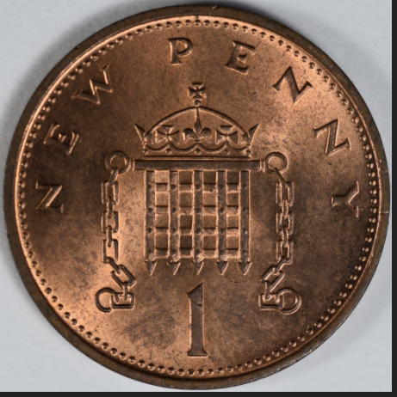
A pound used to be worth 20 shillings. Each shilling was worth 12 pennies. Britain converted to a system where one shilling was worth 5 “new pence” in 1971, with “decimalization”.

If somebody owed you 2 pounds, 4 shillings, sixpence in the old currency, how much did they owe you in the new currency?

Answer. Pounds did not change. Under the old system, a pound was 20 shillings. Under the new system, this means a pound was worth 20*5 new pence, which is 100p.

The 4 shillings would be worth 20p in new pence. The sixpence is half a shilling so it would be worth .5*5p = 2 ½ p.

Thus, they owe you 2 pounds, 22.5p, or 2.225 pounds.

The old penny was the British version of the Roman denarius, mentioned in the Bible. It was a small silver coin. Under King George III, Britain switched from small silver pennies to large copper pennies. They still used the abbreviation “d” for pennies, though (for “denarius”), so if you were owed 20 shillings, sixpence, that would be 20s, 6d. Nowadays they use “p” for new pence.

Britain also changed from the Imperial units of feet, pints, and pounds that we still use in America to the Metric units of meters, liters, and kilograms.
