Mr. Rasmusen
November 13, 2022

Handout: Myriads and Translation

Revelation 5:11 shows three different ways you might translate from Greek to
English :
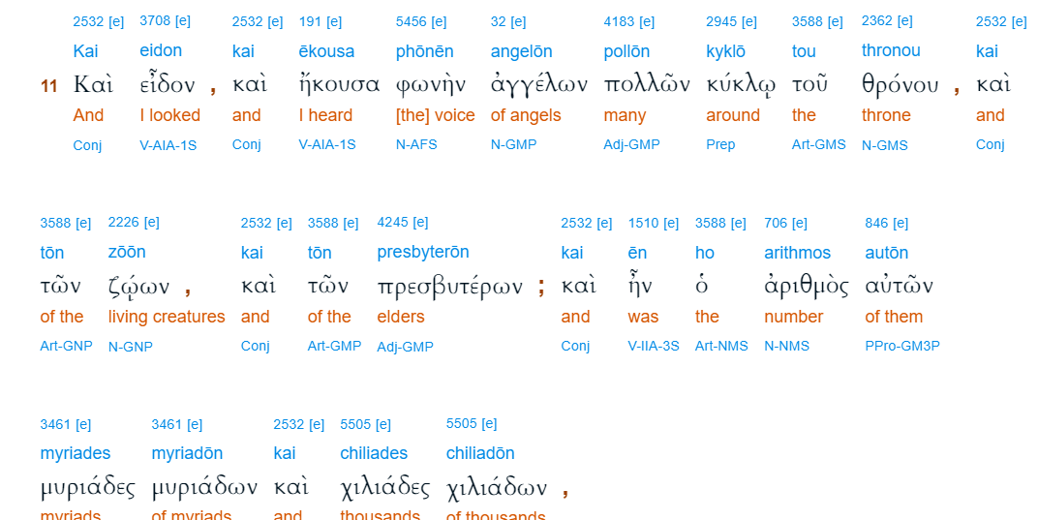
King James Bible
And I beheld, and I heard the voice of many angels round about the throne and the beasts and the elders: and the number of them was ten thousand times ten thousand, and thousands of thousands;

New American Standard Bible
Then I looked, and I heard the voices of many angels around the throne and the living creatures and the elders; and the number of them was myriads of myriads, and thousands of thousands,

New Living Translation
Then I looked again, and I heard the voices of thousands and millions of angels around the throne and of the living beings and the elders.

Genesis 24:60. And they blessed Rebekah and said to her, “Our sister, may you
become thousands of ten thousands, and may your offspring possess the gate of those
who hate him!”

