March 8, 2022. HANDOUT on Focussing Your Attention Mr. Rasmusen

As background, you should know that Drona, the teacher, is a Brahmin, a man born into the priestly class. He is teaching the sons of Kuru, the king, and their cousins the sons of Pandu, who will fight a giant war against each other later in the story when they grow up. Yudhistra is the oldest son of Pandu, and is the smartest one. Bhima is the second oldest, and is the strongest one. Arjuna is the third oldest, and is the best warrior. This story is useful enough for Phd students (23-year old students studying to be professors) that I included it in my 2001 book, Readings in Games and Information.
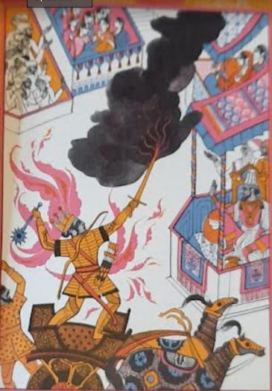
One day when their education was finished, Drona wished to test them in the use of the bow. He had an artificial bird set on the top of a tree as a target; then he called them all together and said, “Take up your bows and arrows and stand here beside me, with your arrows fixed on the bowstring, aiming at the bird. When I give the order, shoot at the bird’s head. I shall give each of you a turn, my children.”
He first addressed Yudhistra, since that prince was the eldest. “Behold,” he said, “the bird of yonder tree.”
“I see it,” answered Yudhistra.
But Drona spoke again to the young prince standing bow in hand. “What else do you see, O Yudhistra? Do you see the tree, or me, or your brothers?”
“I see the tree and you, my brothers, and the bird,” replied the eldest son of Pandu.
And Drona was vexed with him and said, “Stand aside! It is not for you to hit the target.”
The master asked the same question of all the sons of Kuru, one after another, and of Bhima and the twins and the other pupils who had come to him from afar. The answer was always the same, “I see the tree and you, my comrades and the bird.” They were all reproachfully told by their teacher to stand aside.
Then Drona turned smiling to Arjuna, saying, “You must hit the target, therefore turn your eyes to it with an arrow fixed on the string.” Arjuna stood aiming at the bird as the master had commanded, and Drona asked him, “Do you see the bird, the tree, and me?”
“I see only the bird,” answered Arjuna, “not the tree or you.”
Then Drona, well pleased, said, “If you see the bird, describe it to me.”
Arjuna said, “I see only the head of the bird, not its body.”
At these words, Drona’s hair stood on end with delight. “Shoot!” he commanded, and Arjuna instantly let fly his arrow and struck off the bird’s head. The master clasped him to his heart, exclaiming, “You will never be vanquished by any foe, and you will win everlasting fame.”

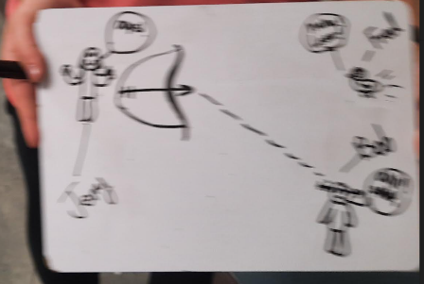
From The Five Sons of King Pandu: The Story of the Mahabharata, retold by Elizabeth Seeger and illustrated by Gordon Lait (1967).

