Mr. Rasmusen

November 4, 2024

**Indulgences**

**Here’s how Catholics can get 8 plenary indulgences during the first week of November**

(https://www.catholicnewsagency.com/news/260215/how-catholics-can-get-8-plenary-indulgences-during-the-first-week-of-november)

Many Catholics may be unaware that they can obtain not one but eight plenary indulgences for departed souls in the first week of November.

For centuries, the Catholic Church widely observed All Saints’ Day (Nov. 1) as an octave, extending the holy celebration to eight days.

The observance was established by Pope Sixtus IV in the 15th century and demoted in the liturgical calendar around the middle of the 20th century, although some Catholics still mark the eight-day observance.

Notably, the Church itself still indirectly acknowledges the ancient eight-day octave in its granting of plenary indulgences for the first week of November.

What is a plenary indulgence? A plenary indulgence is a grace granted by the Catholic Church through the merits of Jesus Christ to remove the temporal punishment due to sin.

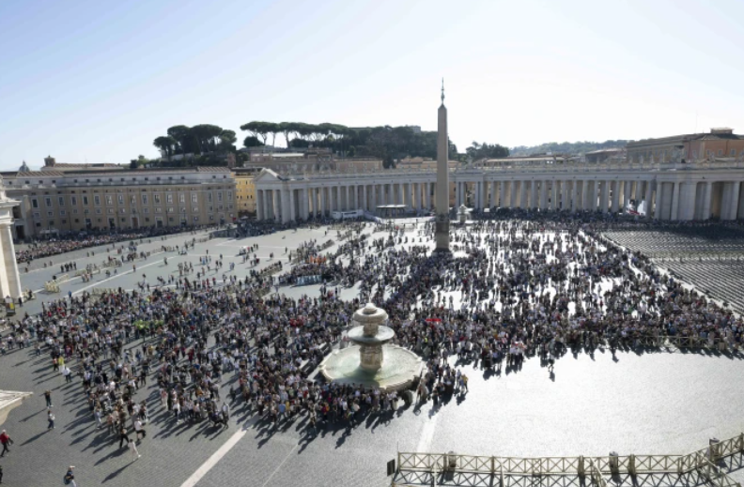

In order to obtain a plenary indulgence the faithful must — in addition to being in the state of grace — both have the interior disposition of complete detachment from sin (even venial sin), have sacramentally confessed their sins and received the Eucharist (either within or outside of Mass), and must pray for the intentions of the Holy Father.

What about the All Saints’ octave? The Vatican’s Apostolic Penitentiary, in its “Enchiridion Indulgentiarum” (“Handbook of Indulgences”), states that the faithful can obtain a plenary indulgence for the faithful departed “every day, from the 1st to the 8th of November,” if, in addition to fulfilling the normal terms of a plenary indulgence, one “devoutly visit[s] a cemetery and at least mentally pray[s] for the dead.”

The conditions for a plenary indulgence can be fulfilled a few days before or after performing the works to gain the indulgence, but it is appropriate that Communion and the prayer take place on the same day that the work is completed.

The All Saints’ octave was notably extended throughout the entire month of November in both 2020 and 2021 amid concerns about avoiding large gatherings of people in churches or cemeteries due to the COVID-19 pandemic.

# **World Plenary Indulgence for the 50th anniversary of the canonisation of St John Macias (https://www.op.org/world-plenary-indulgence-for-the-50th-anniversary-of-the-canonisation-of-st-john-macias/)**

On 8 September 2024, in Rome, on the occasion of the solemn celebrations in honour of St. John Macias for the 50th anniversary of his canonisation, the Apostolic Penitentiary has granted the Plenary Indulgence.

According to the decree, the indulgence can be obtained, subject to the usual conditions, by going on pilgrimage to a church of the Order to attend a jubilee celebration or at least to pray before the relics of the saint, concluding with the Our Father, the Creed, and the invocations of the Blessed Virgin Mary and St. John Macias.

For people who cannot leave the house, they can gain indulgence by joining in the celebrations spiritually. The concession applies not only to Peru, but to the whole world.

