November 4, 2024

Mr Rasmusen’s class

**Luther’s 95 Theses**

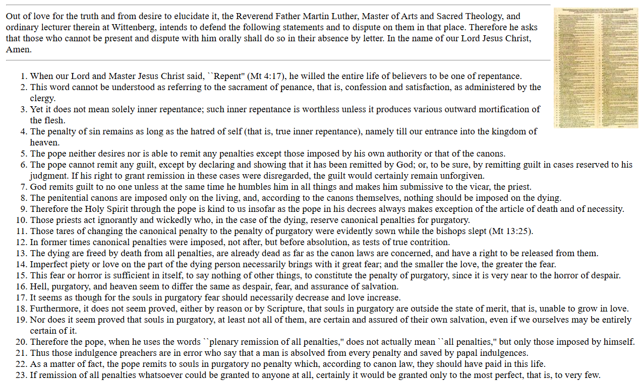

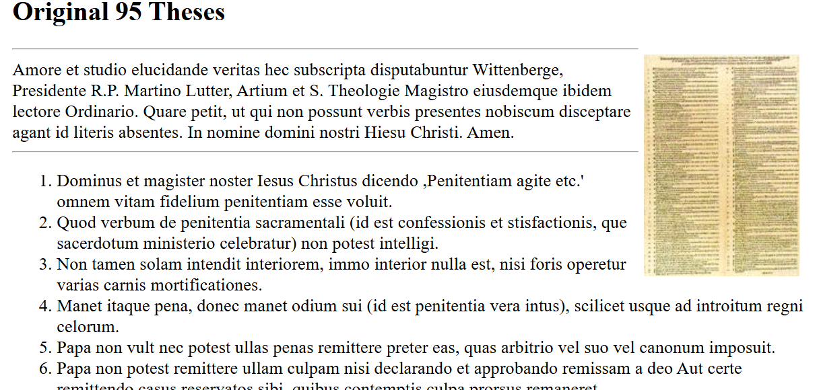The originals were in Latin, not German: