November 13, 2024

Mr. Rasmusen

**מנא מנא תקל ופרסין Mene, Mene, Tekel, Upharsin**

**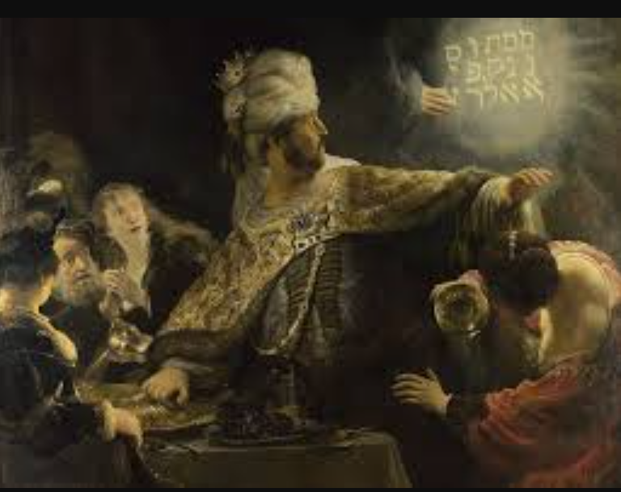**

**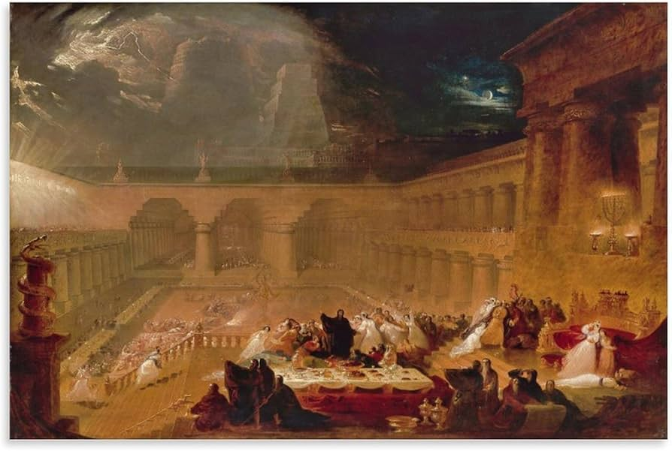**

**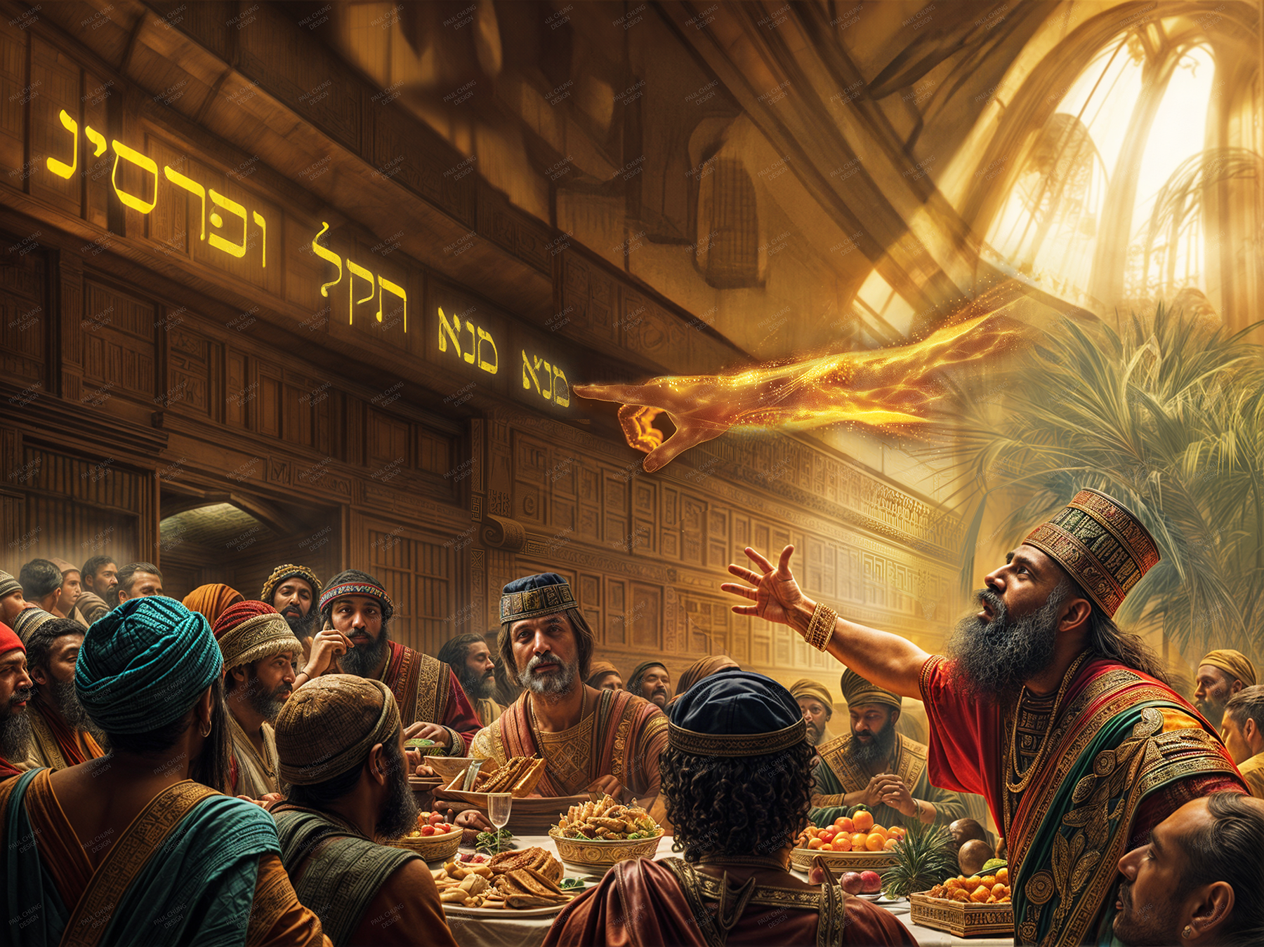**

## 

Rembrandt

John Martin

Paul Chung

See also <https://thoughtsonpapyrus.com/2023/02/19/the-feast-of-belshazzar-5-paintings/>

**Daniel 5.**  **Belshazzar the king** made a great feast to a thousand of his lords, and drank wine before the thousand. Belshazzar, whiles he tasted the wine, commanded to bring the golden and silver vessels which his father Nebuchadnezzar had taken out of the temple which was in Jerusalem; that the king, and his princes, his wives, and his concubines, might drink therein. Then they brought the golden vessels that were taken out of the temple of the house of God which was at Jerusalem; and the king, and his princes, his wives, and his concubines, drank in them. They drank wine, and praised the gods of gold, and of silver, of brass, of iron, of wood, and of stone.

**In the same hour came forth fingers of a man's hand, and wrote over against the candlestick upon the plaister of the wall** of the king's palace: and the king saw the part of the hand that wrote. Then the king's countenance was changed, and his thoughts troubled him, so that the joints of his loins were loosed, and his knees smote one against another.

The king cried aloud to bring in the astrologers, the Chaldeans, and the soothsayers. And the king spake, and said to the wise men of Babylon, Whosoever shall read this writing, and shew me the interpretation thereof, shall be clothed with scarlet, and have a chain of gold about his neck, and shall be the third ruler in the kingdom.

Then came in all the king's wise men: but they could not read the writing, nor make known to the king the interpretation thereof. Then was king Belshazzar greatly troubled, and his countenance was changed in him, and his lords were astonied. Now the queen by reason of the words of the king and his lords came into the banquet house: and the queen spake and said, O king, live for ever: let not thy thoughts trouble thee, nor let thy countenance be changed: There is a man in thy kingdom, in whom is the spirit of the holy gods; and in the days of thy father light and understanding and wisdom, like the wisdom of the gods, was found in him; whom the king Nebuchadnezzar thy father, the king, I say, thy father, made master of the magicians, astrologers, Chaldeans, and soothsayers; Forasmuch as an excellent spirit, and knowledge, and understanding, interpreting of dreams, and shewing of hard sentences, and dissolving of doubts, were found in the same Daniel, whom the king named Belteshazzar: now let Daniel be called, and he will shew the interpretation.

Then was Daniel brought in before the king. And the king spake and said unto Daniel, Art thou that Daniel, which art of the children of the captivity of Judah, whom the king my father brought out of Jewry? I have even heard of thee, that the spirit of the gods is in thee, and that light and understanding and excellent wisdom is found in thee. And now the wise men, the astrologers, have been brought in before me, that they should read this writing, and make known unto me the interpretation thereof: but they could not shew the interpretation of the thing: And I have heard of thee, that thou canst make interpretations, and dissolve doubts: now if thou canst read the writing, and make known to me the interpretation thereof, thou shalt be clothed with scarlet, and have a chain of gold about thy neck, and shalt be the third ruler in the kingdom.

Then Daniel answered and said before the king, Let thy gifts be to thyself, and give thy rewards to another; yet I will read the writing unto the king, and make known to him the interpretation. O thou king, the most high God gave Nebuchadnezzar thy father a kingdom, and majesty, and glory, and honour: And for the majesty that he gave him, all people, nations, and languages, trembled and feared before him: whom he would he slew; and whom he would he kept alive; and whom he would he set up; and whom he would he put down. But when his heart was lifted up, and his mind hardened in pride, he was deposed from his kingly throne, and they took his glory from him:nd he was driven from the sons of men; and his heart was made like the beasts, and his dwelling was with the wild asses: they fed him with grass like oxen, and his body was wet with the dew of heaven; till he knew that the most high God ruled in the kingdom of men, and that he appointeth over it whomsoever he will.

And thou his son, O Belshazzar, hast not humbled thine heart, though thou knewest all this; But hast lifted up thyself against the Lord of heaven; and they have brought the vessels of his house before thee, and thou, and thy lords, thy wives, and thy concubines, have drunk wine in them; and thou hast praised the gods of silver, and gold, of brass, iron, wood, and stone, which see not, nor hear, nor know: and the God in whose hand thy breath is, and whose are all thy ways, hast thou not glorified:

Then was the part of the hand sent from him; and this writing was written. And this is the writing that was written, **Mene, Mene, Tekel, Upharsin.**

This is the interpretation of the thing:

***Mene;*** *God hath numbered thy kingdom, and finished it.*

***Tekel;*** *Thou art weighed in the balances, and art found wanting.*

***Peres;*** *Thy kingdom is divided, and given to the Medes and Persians.*

Then commanded Belshazzar, and they clothed Daniel with scarlet, and put a chain 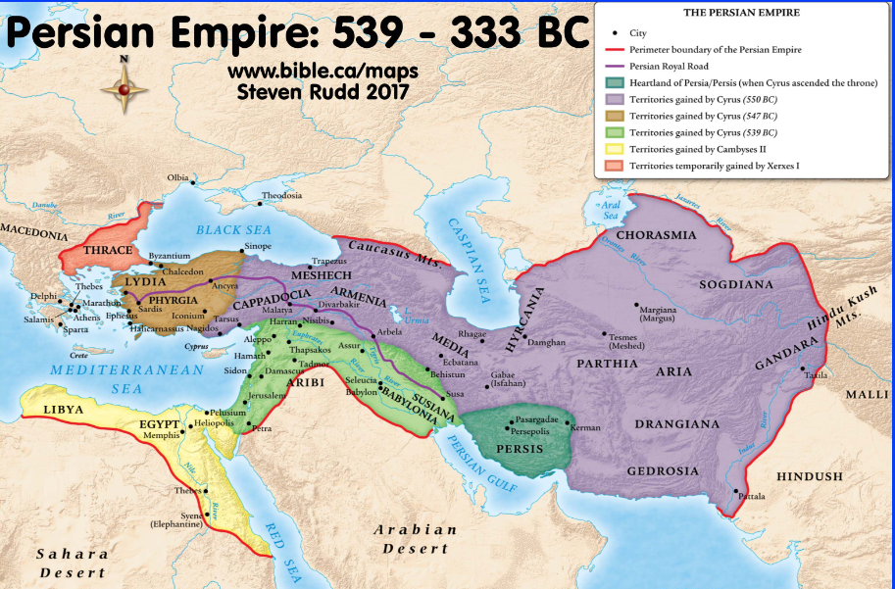of gold about his neck, and made a proclamation concerning him, that he should be the third ruler in the kingdom. In that night was Belshazzar the king of the Chaldeans slain. And Darius the Median took the kingdom, being about threescore and two years old.

[WIKIPEDIA:](https://en.wikipedia.org/wiki/Belshazzar's_feast) “None of the Chaldean wise men are able to even read, let alone interpret, the writing on the wall, but Daniel does so by supplying vowels in two different ways, first so the words are read as nouns, then as verbs.

The nouns are monetary weights: a *mənê*, equivalent to a Jewish mina or sixty [shekels](https://en.wikipedia.org/wiki/Shekel) (several ancient versions have only one *mənê* instead of two); a *təqêl*, equivalent to a shekel; and *p̄arsîn*, meaning "half-pieces".The last involves a word-play on the name of the Persians (*pārās* in Hebrew), suggesting not only that they are to inherit Belshazzar's kingdom, but that they are two peoples, Medes and Persians.

Daniel then interprets the words as verbs, based on their roots: *mənê* is interpreted as meaning "numbered"; *təqêl*, from a root meaning to weigh, as meaning "weighed" (and found wanting); and *pərês* (פְּרַס‎), the singular form of *p̄arsîn*, from a root meaning "to divide", denoting that the kingdom is to be "divided" and given to the Medes and Persians.  If the "half-pieces" means two half-shekels, then the various weights—a *mənê* or sixty shekels, another shekel, and two half-shekels—add up to 62, which the tale gives as the age of [Darius the Mede](https://en.wikipedia.org/wiki/Darius_the_Mede), indicating that God's will is being worked out.

The phrase **"**[**writing on the wall**](https://en.wiktionary.org/wiki/writing_on_the_wall)**"** has grown to be a popular idiomatic expression referring to the foreshadowing of any impending doom, misfortune, or end. A person who does not or refuses to "see the writing on the wall" is being described as ignorant to the signs of a cataclysmic event that will likely occur in the near future.”

A mina is about one pound (18 ounces--

A shekel is about 1/3 ounce, which equals two tablespoons of water, or a half-dollar.

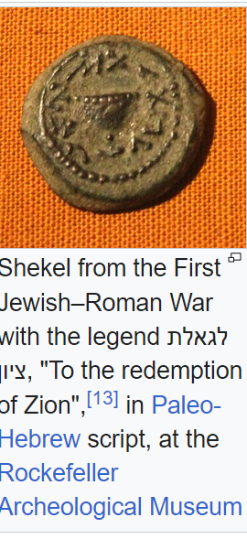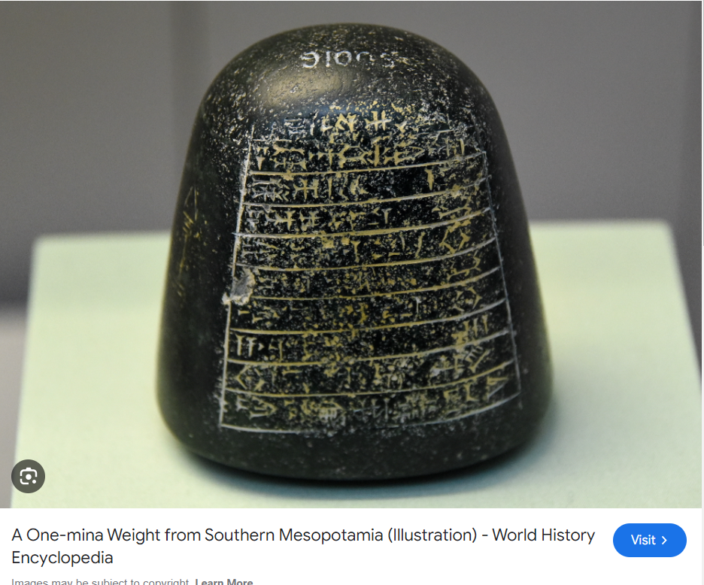

Johnny Cash's first recorded Gospel song was ["Belshazzar,"](https://www.youtube.com/watch?v=6pAvKBwCTTU) in 1957.

[“MENE, MENE, TEKEL, UPHARSIN ()”](https://www.jewishencyclopedia.com/articles/10678-mene-mene-tekel-upharsin) Jewish Encyclopedia, is good on the linguistic details, which are obscure. The language was Aramaic, which is written without any vowels. Lacking vowels, the words are ambiguous.

From Wikipedia, [Biblical Aramaic](https://en.wikipedia.org/wiki/Biblical_Aramaic), here is where Aramaic is used in the Old Testament:

[Genesis](https://en.wikipedia.org/wiki/Book_of_Genesis) 31:47 – translation of a Hebrew placename, Jegar-Sahadutha (Strong's #H3026)

* [Proverbs](https://en.wikipedia.org/wiki/Book_of_Proverbs) 31:2 – the Aramaic word *bar* is used instead of the usual Hebrew *ben*, both meaning "son"
* [Jeremiah](https://en.wikipedia.org/wiki/Book_of_Jeremiah) 10:11 – a single sentence denouncing [idolatry](https://en.wikipedia.org/wiki/Idolatry) occurs in the middle of a Hebrew text.
* [**Daniel**](https://en.wikipedia.org/wiki/Book_of_Daniel)**2:4b–7:28 – five stories about**[**Daniel**](https://en.wikipedia.org/wiki/Daniel_(biblical_figure))**and his**[**colleagues**](https://en.wikipedia.org/wiki/Shadrach,_Meshach,_and_Abednego)**, and an**[**apocalyptic**](https://en.wikipedia.org/wiki/Apocalyptic_literature)**vision.**
* [**Ezra**](https://en.wikipedia.org/wiki/Book_of_Ezra)**4:8–6:18 and 7:12–26 – quotations of documents from the 5th century BCE on the restoration of the**[**Temple in Jerusalem**](https://en.wikipedia.org/wiki/Temple_in_Jerusalem)**.**

From Wikipedia’s [Aramaic:](https://en.wikipedia.org/wiki/Aramaic) [Neo-Aramaic languages](https://en.wikipedia.org/wiki/Neo-Aramaic_languages)are still spoken in the 21st century as a [first language](https://en.wikipedia.org/wiki/First_language)by many communities of [Assyrians](https://en.wikipedia.org/wiki/Assyrian_people), [Mizrahi Jews](https://en.wikipedia.org/wiki/Mizrahi_Jews)(in particular, the [Jews of Kurdistan](https://en.wikipedia.org/wiki/Jews_of_Kurdistan)/[Iraqi Jews](https://en.wikipedia.org/wiki/Iraqi_Jews)), and [Mandaeans](https://en.wikipedia.org/wiki/Mandaeans)of the [Near East](https://en.wikipedia.org/wiki/Near_East), with the main Neo-Aramaic languages being [Suret](https://en.wikipedia.org/wiki/Suret_language)(~240,000 speakers) and [Turoyo](https://en.wikipedia.org/wiki/Turoyo_language)(~250,000 speakers). [Western Neo-Aramaic](https://en.wikipedia.org/wiki/Western_Neo-Aramaic)(~3,000)[[47]](https://en.wikipedia.org/wiki/Aramaic" \l "cite_note-48)persists in only two villages in the [Anti-Lebanon Mountains](https://en.wikipedia.org/wiki/Anti-Lebanon_Mountains)in western [Syria](https://en.wikipedia.org/wiki/Syria).