November 10, 2024

Mr. Rasmusen’s math class, erasmuse61@gmail.com

**Zero Factorial**

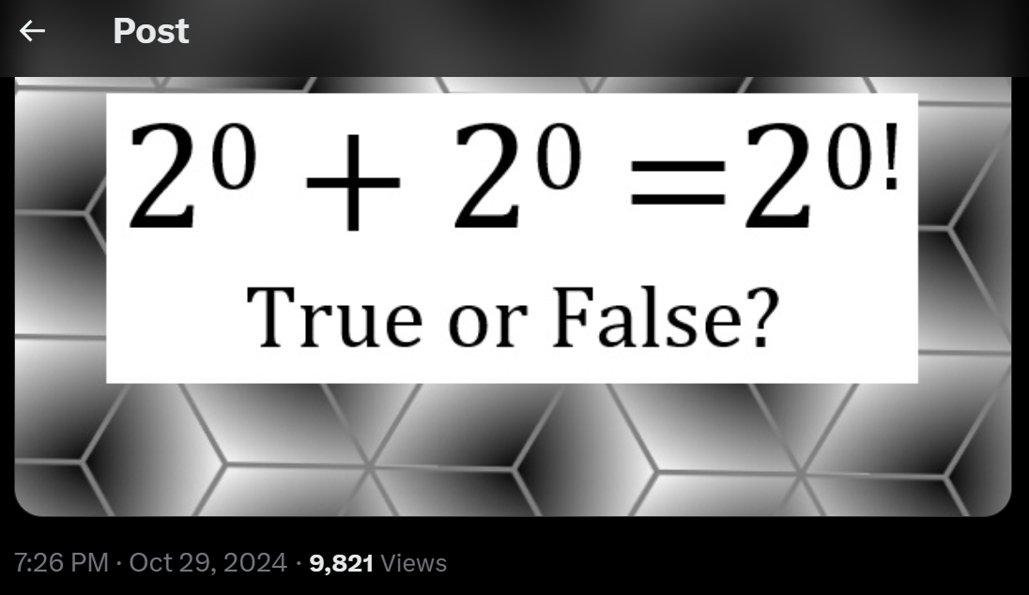

TRUE!

2^0 + 2^0 = 1 + 1 = 2^{0!} = 2^1 = 2.

0!=1 by definition, but that is the only good definition. Like 2^3 = 2*2*2 by definition. But 2*2*2 = 8 NOT by definition. We figure it out from other things we know.

3!, {Jael, Luke, Moses} 6 ways

2! {Jael, Luke} 2 ways

1! {Jael} 1 way

0! {} empty set. Like in Python, print(“”) or the empty list empty_list = [].

There is one and only one way to arrange the empty set: {}. Thus, 0! = 1.

How about negative factorials? It isn’t defined, and you can’t have negative ways to arrange objects, so there’s no best way to define it. There are three reasonable ways you could do it.

Definition (1)

(-3)! = (-3)(-2)(-1) = -6.

(-4)! =(-4)(-3)(-2)(-1) = 24.

Definition (2)

(-3)! = -3! = - (3*2*1) = -6

(-4)! = -4! = - (4*3*2*1) = -24

Definition (3)

(-3)! = 3! = (3*2*1) = 6

(-4)! = 4! = (4*3*2*1) = 24

Which of the three definitions do you like best?

Method (1) is what is best just using the same pattern as positive factorials.

Methods (2) and (3), though, look much better on a graph. Try graphing all three methods, and you will see.

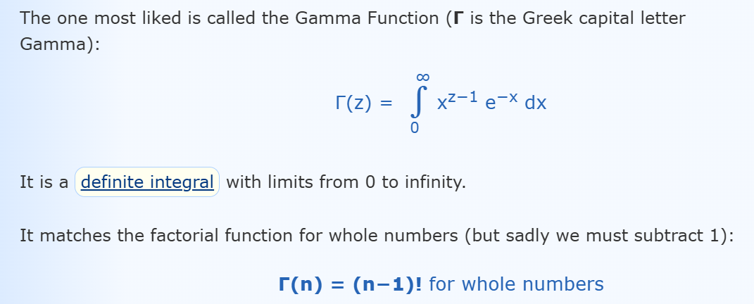

We can also think about what to do with factorials of non-integers, such as 2.5!. To get those, we would want to INTERPOLATE between the integer factorials, and find a function that makes the interpolated points look nice. “Nice” is in the eye of the beholder.

One way is to draw straight diagonal lines between the integer points. Then since 2! = 2 and 3! = 6, 25! = 4, halfway between 2 and 6 since 2.5 is halfway between 2 and 3.

Another way is to draw a smooth curve <https://www.mathsisfun.com/numbers/gamma-function.html> is very good on this. The favorite function for doing that is called the Gamma Function. It uses calculus, and the formula is this: