February 6, 2024

**The Right Triangle Area Lemma:** The area of a right triangle is .5*base*height.

**Proof.** By drawing lines at right angles from the two acute-angle vertices of our right triangle X, we can construct a rectangle as in Figure 1.

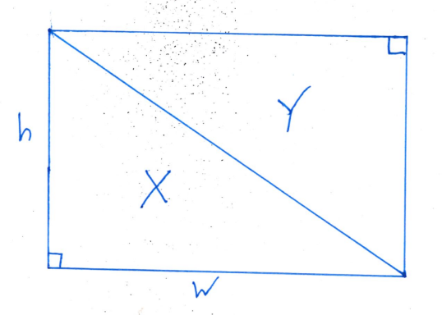 The rectangle’s area is width*height.

The upper triangle Y has the same three sides as our original triangle , so it has the same area as X.

Thus, the rectangle’s area equals two times the area of the original triangle: width*height = 2X, and

X = .5*width*height.

Q. E. D.

**The Triangle Area Theorem:** The area of a triangle is .5*base*height.

**Proof.** Move the triangle around so its longest side is on the bottom, as in the figure. Draw the height line from the bottom line to the top vertex. This will divide the triangle into two right triangles, X and Y, with bases a and b. From the Lemma, X = .5*a*h and Y = .5 *b*h.

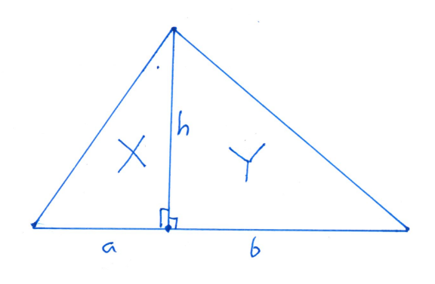

Thus the total area of our triangle is X + Y = .5*a*h + .5 *b*h.

= .5(a*h + b*h)

= .5h(a + b),

but .5h(a + b) is half the height times the base of the triangle.

Q .E. D.