February 1, 2025

A Mathematician's Lament", Lockhart.

A Mathematician's Lament", Lockhart.
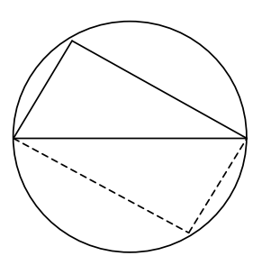
“Take the triangle and rotate it around so it makes a foursided box inside the circle. Since the triangle got turned completely around, the sides of the box must be parallel, so it makes a parallelogram. But it can’t be a slanted box because both of its diagonals are diameters of the circle, so they’re equal, which means it must be an actual rectangle. That’s why the corner is always a right angle.”

“Since the triangle got rotated halfway around the circle, the tip must end up exactly opposite from where it started. That’s why the diagonal of the box is a diameter.”

