February 16, 2024
How To Show Pi Is between 2 and 4

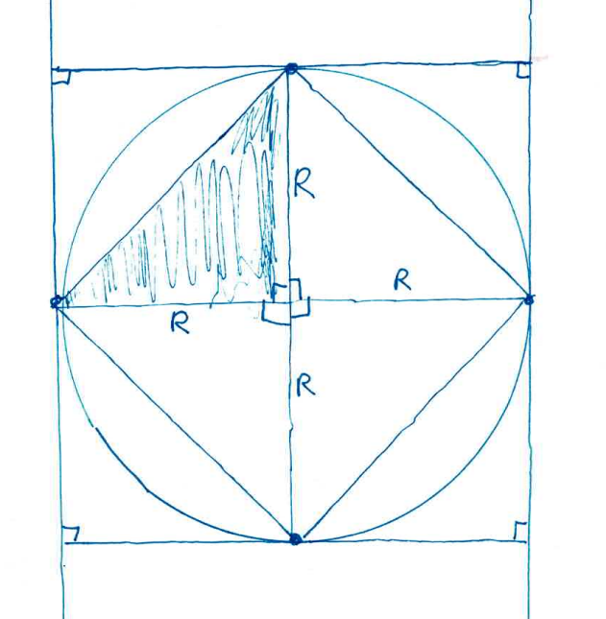
The definition of pi is Circumference/Diameter of a circle. When we say that Circumference = pi*diameter, what we are really saying is that whatever the size of the circle, the Circumference/Diameter is the same number, and we call that number pi.

But how do we know how big pi? You could just measure it, using a string to find out the length of the circumference and then use a ruler to find out the radius. Since we know all circles have the same Circumference/Diameter, that would be a good estimate. In fact, we should do that in class and see how accurate we can get. That is the scientific approach: measure and see what you get.

We can also try to prove it mathematically, instead of scientifically, using logic instead of measurement. That’s what we’ll do here, using the diagram.

Theorem 1: Pi is less than 4.

Proof: We can draw a square to enclose the circle, touching it at four points on west, east, north and south. Each side of the square will have length 2R
Thus, the perimeter of the square is 4*2R, which equals 8R, which equals 4*Diameter.
The perimeter is greater than the circumference, so

4*Diameter > Circumference, which means 4 > Circumference/Diameter = Pi,

so

Pi = Circumference/Diameter < 4.
Q.E.D.

Theorem 2: Pi is greater than 2.

Proof: We can draw a square just inside the circle, touching it at four points on west, east, north and south, though this square will be tilted. The area of the circle is pi*R*R.
The area of the square can be found by dividing it into four equal-sized triangles.
Each triangle has a base of R and a height of R, so it has area R*R/2.
Adding them all up, we get the area of the square to be 4*(R*R/2), which equals 2*R*R.
The area of the circle is greater than the area of the square, since the square is inside the circle, so

pi*R*R > 2*R*R,

so pi > 2. Q. E. D.

