**April 5, 2022. Mining Photos Mr Rasmusen, 7th grade math**

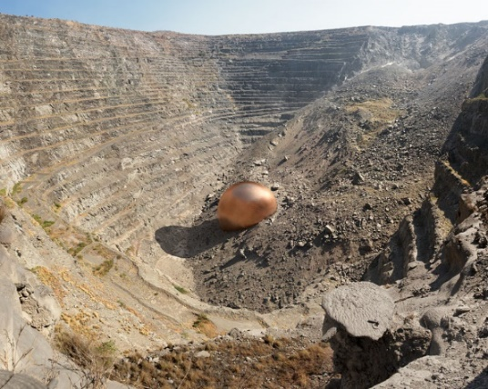

6. The sphere in this picture represents all the copper taken from the Palabora Mine in South Africa from 1964 to 2002, when they reached the “economic depth”. The highest-grade copper is 1% of the ore. I estimate it has a radius of 50 feet. What is its volume? <http://dillonmarsh.com/copper.html>, https://www.mining-technology.com/projects/palabora/

*The volume of a sphere is (4/3) pi *r^3, which is 1.33*3.14*50*50*50 = 522,025 cubic feet. (calc)*

