**January 15, 2025**

**The Siege of Syracuse and the Death of Archimedes THI SIS OLD, SEE THE SUBSTDACK THAT REPLACES IT**

From Plutarch, The Life of Marcellus, [https://penelope.uchicago.edu/Thayer/E/Roman/Texts/Plutarch/Lives/Marcellus*.html](https://penelope.uchicago.edu/Thayer/E/Roman/Texts/Plutarch/Lives/Marcellus*.html))

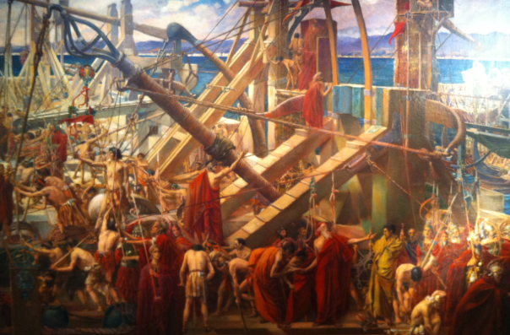

[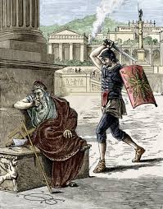](https://www.google.com/imgres?q=The%20Siege%20of%20Syracuse%20and%20the%20Death%20of%20Archimedes&imgurl=https%3A%2F%2Fmedia.sciencephoto.com%2Fh4%2F01%2F02%2F66%2Fh4010266-400px-wm.jpg&imgrefurl=https%3A%2F%2Fwww.sciencephoto.com%2Fmedia%2F223210%2Fview%2Fdeath-of-archimedes-in-sack-of-syracuse&docid=W4p9N0B9UZc2VM&tbnid=bpF5HnFjhtfhOM&vet=12ahUKEwi56_W5jfiKAxWQ8MkDHbe7IzIQM3oECE0QAA..i&w=313&h=400&hcb=2&ved=2ahUKEwi56_W5jfiKAxWQ8MkDHbe7IzIQM3oECE0QAA)

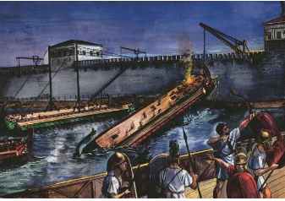 When, therefore, the Romans assaulted them by sea and land, the Syracusans were stricken dumb with terror; they thought that nothing could withstand so furious an onset by such forces. But Archimedes began to ply 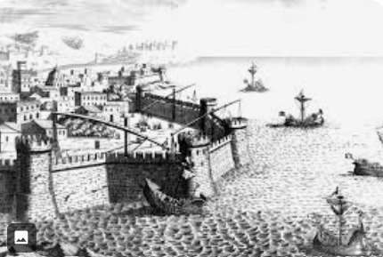 his engines, and shot against the land forces of the assailants all sorts of missiles and immense masses of stones, which came down with incredible din and speed; nothing whatever could ward off their weight, but they knocked down in heaps those who stood in their way, and threw their ranks into confusion. At the same time huge beams were suddenly projected over the ships from the walls, which sank some of them with great weights plunging down from on high; others were seized at the prow by iron claws, or beaks like the beaks of cranes, drawn straight up into the air, and then plunged stern foremost into the depths, or were turned round and round by means of enginery within the city, and dashed upon the steep cliffs that jutted out beneath the wall of the city, with great destruction of the fighting men on board, who perished in the wrecks. Frequently, too, a ship would be lifted out of the water into mid-air, whirled hither and thither as it hung there, a dreadful spectacle, until its crew had been thrown out and hurled in all directions, when it would fall empty upon the walls, or slip away from the clutch that had held it. As for the engine which Marcellus was bringing up on the bridge of ships, and which was called "sambuca" from some resemblance it had to the musical instrument of that name,​ while it was still some distance off in its approach to the wall, a stone of ten talents' weight​ was discharged at it, then a second and a third; some of these, falling upon it with great din and surge of wave, crushed the foundation of the engine, shattered its frame-work, and dislodged it from the platform, so that Marcellus, in perplexity, ordered his ships to sail back as fast as they could, and his land forces to retire.

Then, in a council of war, it was decided to come up under the walls while it was still night, if they could; for the ropes which Archimedes used in his engines, since they imparted great impetus to the missiles cast, would, they thought, send them flying over their heads, but would be ineffective at close quarters, where there was no place for the cast. Archimedes, however, as it seemed, had long before prepared for such an emergency engines with a range adapted to any interval and missiles of short flight, and through many small and contiguous openings in the wall short-range engines called scorpions could be brought to bear on objects close at hand without being seen by the enemy.

When, therefore, the Romans came up under the walls, thinking themselves unnoticed, once more they encountered a great storm of missiles; huge stones came tumbling down upon them almost perpendicularly, and the wall shot out arrows at them from every point; they therefore retired. And here again, when they were some distance off, missiles darted forth and fell upon them as they were going away, and there was great slaughter among them; many of their ships, too, were dashed together, and they could not retaliate in any way upon their foes. For Archimedes had built most of his engines close behind the wall, and the Romans seemed to be fighting against the gods, now that countless mischiefs were poured out upon them from an invisible source.

However, Marcellus made his escape, and jesting with his own artificers and engineers, "Let us stop," said he, "fighting against this geometrical Briareus, who uses our ships like cups to ladle water from the sea, and has whipped and driven off in disgrace our sambuca, and with the many missiles which he shoots against us all at once, outdoes the hundred-handed monsters of mythology." For in reality all the rest of the Syracusans were but a body for the designs of Archimedes, and his the one soul moving and managing everything; for all other weapons lay idle, and his alone were then employed by the city both in offence and defence. At last the Romans became so fearful that, whenever they saw a bit of rope or a stick of timber projecting a little over the wall, "There it is," they cried, "Archimedes is training some engine upon us," and turned their backs and fled. Seeing this, Marcellus desisted from all fighting and assault, and thenceforth depended on a long siege.

And yet Archimedes possessed such a lofty spirit, so profound a soul, and such a wealth of scientific theory, that although his inventions had won for him a name and fame for superhuman sagacity, he would not consent to leave behind him any treatise on this subject, but regarding the work of an engineer and every art that ministers to the needs of life as ignoble and vulgar, he devoted his earnest efforts only to those studies the subtlety and charm of which are not affected by the claims of necessity. These studies, he thought, are not to be compared with any others; in them the subject matter vies with the demonstration, the former supplying grandeur and beauty, the latter precision and surpassing power. For it is not possible to find in geometry more profound and difficult questions treated in simpler and purer terms.

Some attribute this success to his natural endowments; others think it due to excessive labour that everything he did seemed to have been performed without labour and with ease. For no one could by his own efforts discover the proof, and yet as soon as he learns it from him, he thinks he might have discovered it himself; so smooth and rapid is the path by which he leads one to the desired conclusion. And therefore we may not disbelieve the stories told about him, how, under the lasting charm of some familiar and domestic Siren, he forgot even his food and neglected the care of his person; and how, when he was dragged by main force, as he often was, to the place for bathing and anointing his body, he would trace geometrical figures in the ashes, and draw lines with his finger in the oil with which his body was anointed, being possessed by a great delight, and in very truth a captive of the Muses. And although he made many excellent discoveries, he is said to have asked his kinsmen and friends to place over the grave where he should be buried a cylinder enclosing a sphere, with an inscription giving the proportion by which the containing solid exceeds the contained.​

Marcellus noticed a certain tower that was carelessly guarded, into which men could be secretly introduced, since the wall near it was easy to surmount. 3 When, therefore, in his frequent approaches to it for holding these conferences, the height of the tower had been carefully estimated, and ladders had been prepared, he seized his opportunity when the Syracusans were celebrating a festival in honour of Artemis and were given over to wine and sport, and before they knew of his attempt not only got possession of the tower, but also filled the wall round about with armed men, before the break of day, and cut his way through the Hexapyla.

When these parts also were in his possession, at break of day Marcellus went down into the city through the Hexapyla, congratulated by the officers under him. He himself, however, as he looked down from the heights and surveyed the great and beauti­ful city, is said to have wept much in commiseration of its impending fate, bearing in mind how greatly its form and appearance would change in a little while, after his army had sacked it. For among his officers there was not a man who had the courage to oppose the soldiers' demand for a harvest of plunder, nay, many of them actually urged that the city should be burned and razed to the ground. This proposal, however, Marcellus would not tolerate at all, but much against his will, and under compulsion, he permitted booty to be made of property and slaves, although he forbade his men to lay hands on the free citizens, and strictly ordered them neither to kill nor outrage nor enslave any Syracusan.

What most of all afflicted Marcellus was the death of Archimedes. For it chanced that he was by himself, working out some problem with the aid of a diagram, and having fixed his thoughts and his eyes as well upon the matter of his study, he was not aware of the incursion of the Romans or of the capture of the city. Suddenly a soldier came upon him and ordered him to go with him to Marcellus. This Archimedes refused to do until he had worked out his problem and established his demonstration, whereupon the soldier flew into a passion, drew his sword, and dispatched him.

Others, however, say that the Roman came upon him with drawn sword threatening to kill him at once, and that Archimedes, when he saw him, earnestly besought him to wait a little while, that he might not leave the result that he was seeking incomplete and without demonstration; but the soldier paid no heed to him and made an end of him.

There is also a third story, that as Archimedes was carrying to Marcellus some of his mathematical instruments, such as sun-dials and spheres and quadrants, by means of which he made the magnitude of the sun appreciable to the eye,​ some soldiers fell in with him, and thinking that he was carrying gold in the box, slew him.

However, it is generally agreed that Marcellus was afflicted at his death, and turned away from his slayer as from a polluted person, and sought out the kindred of Archimedes and paid them honour.

When I was a quaestor, I discovered his tomb, ignored by the Siracusans, for they categorically denied his existence, surrounded everywhere and covered with Bushes. I remembered, in fact, some modest senaries which, according to tradition, had been inscribed in his tomb and which clearly stated that a sphere with a cylinder had been placed at the top of it. One day when I was looking all over the land, because there are a great number of tombs next to the door of Agrigento, I noticed a small column that did not protrude much from the undergrowth, on which there were represented the figure of a sphere and a cylinder. And I immediately told the Siracusians, some of whose elders went with me, that in my opinion that was what I was looking for.

Cicero, *Tusculanae Disputationes* V, XXIII–64,65

Many men were sent with sickles that cleaned and made the place accessible. When they opened an entrance, we approached the front face of the base. There was an epigram with the verses erased at the end, almost halved. Thus the noblest city of Greece, once even the most learned, would have ignored the tomb of its most brilliant citizen, if it had not been shown to them by a man from Arpino.

Cicero, *Tusculanae Disputationes* V, XXIII–65,66

<https://www.labrujulaverde.com/en/2019/03/when-cicero-found-archimedes-tomb-in-syracuse/>

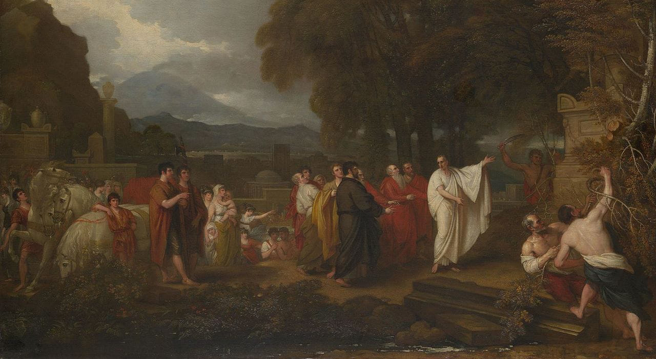

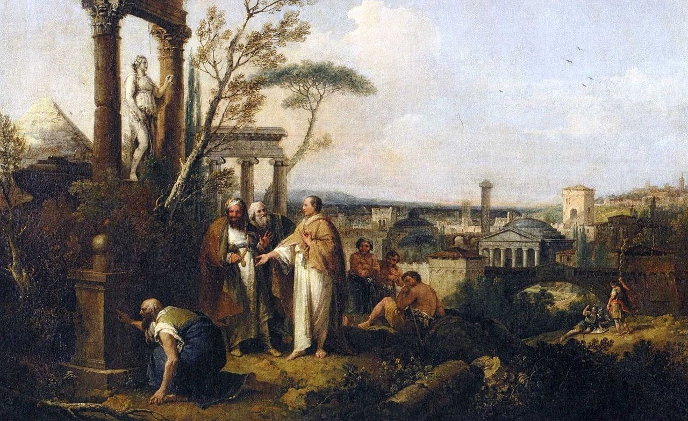**icero discovering the tomb of Archimedes, by Francesco Zuccarelli, 1747 / photo**[public Domain on Wikimedia Commons](https://commons.wikimedia.org/wiki/File:Cicero_entdeckt_das_Grabmal_des_Archimedes_(Zuccarelli).jpg)

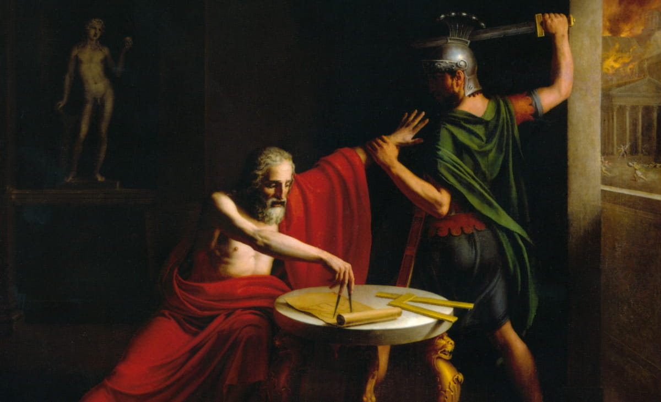sdsadasdasdadasd**Cicero discovering the tomb of Archimedes, by Francesco Zuccarelli, 1747 / photo**[public Domain on Wikimedia 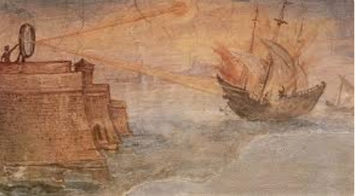Commons](https://commons.wikimedia.org/wiki/File:Cicero_entdeckt_das_Grabmal_des_Archimedes_(Zuccarelli).jpg) dsfdsfdffsdfdsfd

**Archimedes’ mirrors in a fresco in the Uffizzi Gallery, painted by Giulio Parigi in 1600 / photo**[public Domain on Wikimedia Commons](https://en.wikipedia.org/wiki/File:Archimedes-Mirror_by_Giulio_Parigi.jpg)

Put in the dates of Macellus. Arhcimees, Cicero.

Make this into a Substack.