The Primrose
Upon this Primrose hill,
Where, if heaven would distill
A shower of rain, each several drop might go
To his own primrose, and grow manna so;
And where their form, and their infinity
Make a terrestrial galaxy,
As the small stars do in the sky;
I walk to find a true love; and I see
That 'tis not a mere woman, that is she,
But must or more or less than woman be.
Yet know I not, which flower
I wish; a six, or four;
For should my true-love less than woman be,
She were scarce anything; and then, should she
Be more than woman, she would get above
All thought of sex, and think to move
My heart to study her, and not to love.
Both these were monsters; since there must reside
Falsehood in woman, I could more abide,
She were by art, than nature falsified.
Live, primrose, then, and thrive
With thy true number five;
And, woman, whom this flower doth represent,
With this mysterious number be content;
Ten is the farthest number; if half ten
Belongs to each woman, then
Each woman may take half us men;
Or—if this will not serve their turn—since all
Numbers are odd, or even, and they fall
First into five, women may take us all.

And though it in the center sit,
Yet when the other far doth roam,
It leans and hearkens after it,
And grows erect, as that comes home.

Such wilt thou be to me, who must,
Like th' other foot, obliquely run;
Thy firmness makes my circle just,
And makes me end where I begun.
A primrose has how many petals?

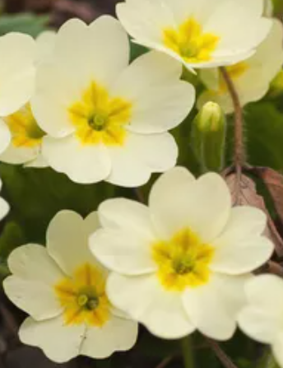

A Valediction: Forbidding Mourning

Our two souls therefore, which are one,
Though I must go, endure not yet
A breach, but an expansion,
Like gold to airy thinness beat.

If they be two, they are two so
As stiff twin compasses are two;
Thy soul, the fixed foot, makes no show
To move, but doth, if the other do.

And though it in the center sit,
Yet when the other far doth roam,
It leans and hearkens after it,
And grows erect, as that comes home.

Such wilt thou be to me, who must,
Like th' other foot, obliquely run;
Thy firmness makes my circle just,
And makes me end where I begun.

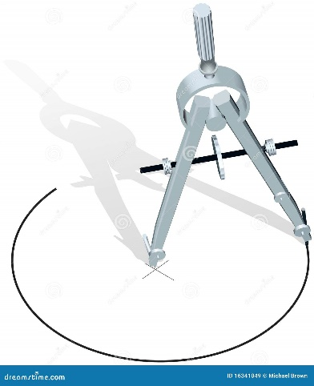

See https://poetrywithmathematics.blogspot.com/.

The Computation
For the first twenty years since yesterday
I scarce believed thou couldst be gone away;
For forty more I fed on favors past,
And forty on hopes that thou wouldst they might last.
Tears drowned one hundred, and sighs blew out two,
A thousand, I did neither think nor do,
Or not divide, all being one thought of you,
Or in a thousand more forgot that too.
Yet call not this long life, but think that I
Am, by being dead, immortal. Can ghosts die?

