March 20, 2024
Mr. Rasmusen
HANDOUT from Huckleberry Finn

[Huck, a teenager, and Jim, an escaped slave, are travelling on a raft on the Mississippi River with two men they met. One man says he is the rightful Duke of Bridgewater and the other says he is Louis XVII, King of France, who was believed to have died as a baby but really escaped.]

DAYLIGHT CAME, BUT WE CONTINUED TO TRAVEL. IT WAS THE FIRST time that Jim and I had traveled during the daytime. After breakfast, the king sat on a corner of the raft, took off his shoes, rolled up his trousers, and let his legs hang in the water. When he was nicely comfortable, he began to read Shakespeare’s play, “Romeo and Juliet.” He was learning certain speeches and when he could say them without looking at the book, the duke began to practice with him. The duke told the king exactly how his voice should sound when saying the speeches, how he should stand, and the motions he should make with his hands.

Next, they practiced fighting with long swords which the duke had made from pieces of wood. The duke called himself King Richard III and taught the king the noble art of sword fighting. They practiced until the king tripped and fell into the river.

After dinner, the duke said, “We’ll want this to be a good show, so we’ll need to add one more scene. Why don’t we do a scene from ‘Hamlet?’ ” Then he stood in a most noble manner, with one leg slightly forward, his arms stretched high, and his head back and looking up at the sky. He began to speak in a loud voice, making long, loud, sad cries, his arms waving wildly and his chest swelling out. It was the best acting that I had ever seen.

The king said that he liked the speech and soon was able to act it as well as the duke. As soon as we came to a small town, we stopped and the duke located a printer and had announcements printed. The following few days, as we traveled down the river, the raft became a very lively place. The king and duke were sword fighting or practicing their speeches all the time.

One morning we came in sight of a small town in the state of Arkansas. We hid the raft in a small stream and left Jim with our supplies. The king, the duke, and I rowed the canoe into town to learn if there was a possibility that we could perform our show here.

We were lucky. A traveling show had arrived that morning and people from the surrounding country were already coming in to see it. That show was to be performed in the afternoon, and the people might stay to see our show if we gave it later. We nailed our printed signs onto trees throughout the town. They read like this:

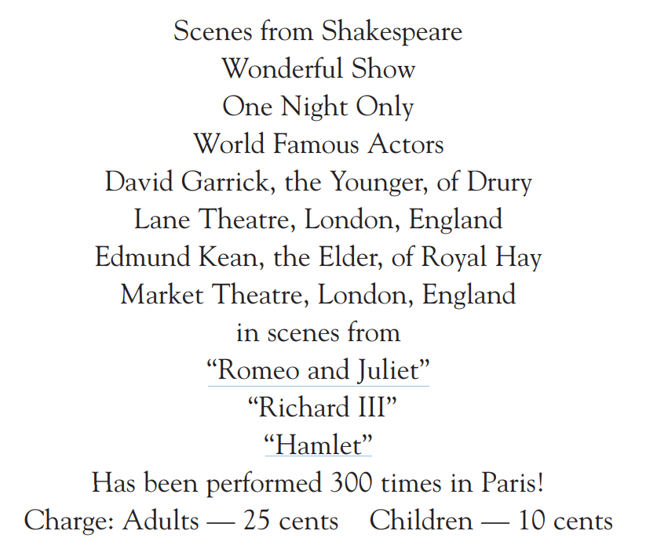

That night we gave our show, but only about twelve people came to see it. The people didn’t understand the show and laughed all the time. That made the duke very angry. Everyone left before the show had ended, except for one boy who was asleep. The duke said that the people were not smart enough for Shakespeare. He said that he knew the type of show that would please them. The next morning he got some large sheets of paper and some black paint and made new signs. This is what he wrote on the signs:

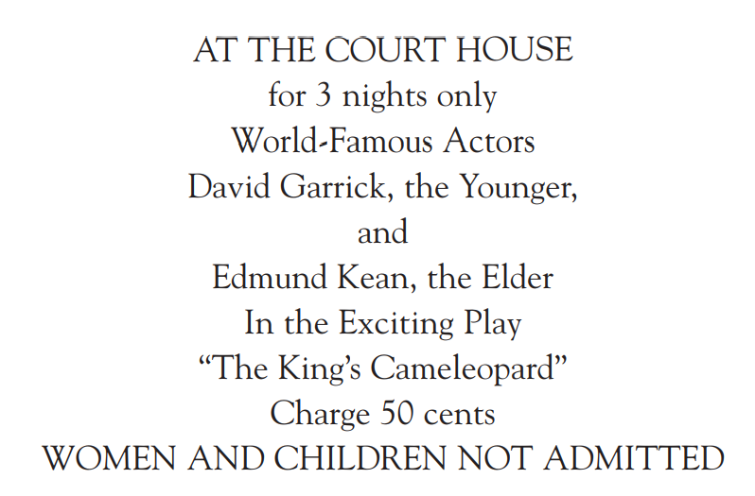

“There,” said the duke, “if that last line doesn’t bring them to the show, I don’t know Arkansas!”

ALL DAY, THE DUKE AND THE KING WORKED TO BUILD A STAGE WITH a curtain and a row of candles for footlights. That night the house was filled with men coming to see the show. The duke came onto the stage in front of the curtain and made a little speech. He praised the show and said that it was the most exciting one that ever was. He told how Edmund Kean was the best actor in the world.

When the duke had got the men very excited and eager to see the show, he opened the curtain and the king came out. He was com pletely naked and his body was painted every bright color imaginable. He looked wild, but it was very funny. The people almost died laughing. The king did a kind of little dance, and the men laughed louder.

They stood up and cheered louder, and the king returned and did the dance one more time. Then he left the stage.

The duke closed the curtain and bowed to the men and said that the show would be performed two more times. He said that he was sorry that they could not perform it more often, but that they must soon return to London. He said if they had succeeded in pleasing them, to please ask other men in the town to come to see the show. Twenty people shouted, “What? Has the show ended? Is that all?”

Suddenly, the angry crowd stood up and began to move toward the stage. Then a tall, good-looking gentleman jumped up and stood on a chair, shouting, “Stop! Listen to me. We were tricked! We’ve been made to look like fools. But do we want the entire town laughing at us. No! What we have to do is to leave here quietly, tell the others that it was a great show, and try to get all the men of the town to come to see it. Then we’ll all be fools together.”

Everyone agreed that he was correct and left quietly. The following day, the men were busy telling other men about the great show. There was a large crowd the second night, and again the king appeared naked with his body brightly painted and again the show lasted only a few minutes. And again the men were angry, but left quietly. On the third night, the crowd was very large, the largest that it had been. But I noticed that the men who had already seen the first or second shows were returning to see the third one. That seemed strange to me. Then the duke and I noticed that every man had a large object under his coat or in his pocket, and I knew from the smell that these objects were old and spoiled fruits, vegetables, and eggs. When the room was so full that no more men could fit into it, the duke said that it was time for him to go on stage and introduce the king. I followed him. When we came near the stage door, he said, “Walk quickly down the street. As soon as we are away from this theater, run to the raft.”

I did as he said, and we both ran to the raft as fast as we could. Soon we were moving away from the shore and out toward the middle of the river. Neither of us said a word. I felt sad for the poor king who had been left behind with the angry crowd. You can imagine my surprise when I heard a voice call out from the tent on the raft, “What happened at the show?” The king had not left the raft to go to the show that night.

We did not dare build a fire or show a light until we were ten miles down the river. Then as Jim and I cooked supper, the king and the duke laughed and laughed at the way that they had tricked the men of that town. They counted the money they had earned—465 dollars—and felt that was good pay for three nights of work.

Later, when they were asleep, Jim said, “Are you surprised at the way the king and duke act, Huck?”

“No, Jim, I’m not. Our duke and king are not honest, but then I don’t think any member of royalty has ever been honest.”

“That’s how I feel too, Jim. But we have them with us, and we’ll have to continue treating them like royalty.”

I didn’t tell Jim what I had suspected for a long time—that the two men traveling with us were not real kings and dukes.

