Mr. Rasmusen

November 13, 2022

**Handout: Myriads and Translation**

Revelation 5:11 shows three different ways you might translate from Greek to

English :

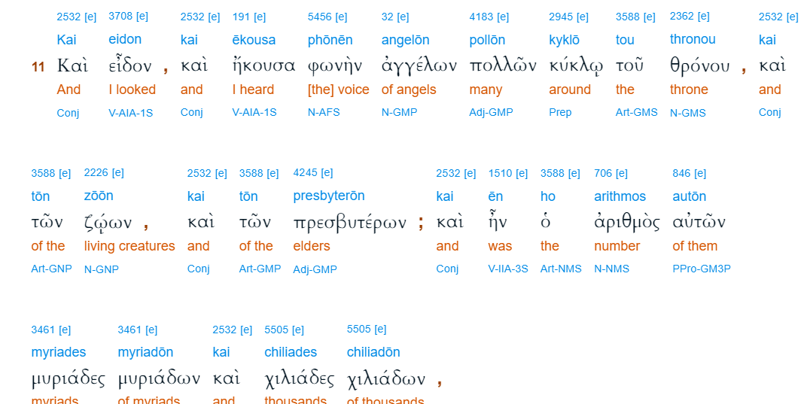

[King James Bible](https://biblehub.com/kjv/revelation/5.htm)  
And I beheld, and I heard the voice of many angels round about the throne and the beasts and the elders: and the number of them was ten thousand times ten thousand, and thousands of thousands;

[New American Standard Bible](https://biblehub.com/nasb_/revelation/5.htm)  
Then I looked, and I heard the voices of many angels around the throne and the living creatures and the elders; and the number of them was myriads of myriads, and thousands of thousands,

[New Living Translation](https://biblehub.com/nlt/revelation/5.htm)  
Then I looked again, and I heard the voices of thousands and millions of angels around the throne and of the living beings and the elders.

**Genesis 24:60.** And they blessed Rebekah and said to her, “Our sister, may you

become thousands of ten thousands, and may your offspring possess the gate of those

who hate him!”