**File Settings**

Done

**Title**

**Description**

**Thumbnail**

Will be cropped to a 3:2 aspect ratio

Upload

Draft

PreviewContinue

Post too long for email

[Learn more](https://support.substack.com/hc/en-us/articles/360038866571-Why-does-it-say-Email-too-long-in-the-post-editor-)

Style

Buttons

More

[Edit email header and footer](https://ericrasmusen.substack.com/publish/settings/preamble)

Choose author

](https://substackcdn.com/image/fetch/f_auto,q_auto:good,fl_progressive:steep/https%3A%2F%2Fsubstack-post-media.s3.amazonaws.com%2Fpublic%2Fimages%2Fa4917a56-0a5c-43d9-b17b-97baf2b38968_794x768.png)](https://substackcdn.com/image/fetch/f_auto,q_auto:good,fl_progressive:steep/https%3A%2F%2Fsubstack-post-media.s3.amazonaws.com%2Fpublic%2Fimages%2Fa4917a56-0a5c-43d9-b17b-97baf2b38968_794x768.png" \t "_blank)

**A Jaunty Pi** *(from* [*Wikipedia*](https://en.wikipedia.org/wiki/File:Pi-symbol_(updated).svg)*)*

In [Part I](https://ericrasmusen.substack.com/p/pi-day-friday) of this essay, I talked about Pi’s value and its irrationality. Does that also make Pi Day valuable and irrational?[1](https://ericrasmusen.substack.com/publish/post/142425993?back=%2Fpublish%2Fposts%2Fdrafts#footnote-1) How about learning more than the 15 digits needed by NASA? Or worthless but rational? Whichever, highly intelligent people are drawn to memorizing digits, just as they are drawn to chess. Think of the celebrated [55-Digit Pi March](https://soundcloud.com/mitmpc/thepimarch), by Coach Tom and his teenage computers, or how Bruce Dan (see *Wikipedia*) recited 144 digits of Pi at a frat party.[2](https://ericrasmusen.substack.com/publish/post/142425993?back=%2Fpublish%2Fposts%2Fdrafts#footnote-2) Or think of the many mathematicians over the ages who have devoted time to computing Pi to more and more digits. Even before calculus was invented, Van Ceulen got up to 35 digits in 1610 (see: Peter Borwein, “[The Amazing Number](http://www.pi314.net/ref/P159.pdf) Pi” (2000)).

](https://substackcdn.com/image/fetch/f_auto,q_auto:good,fl_progressive:steep/https%3A%2F%2Fsubstack-post-media.s3.amazonaws.com%2Fpublic%2Fimages%2Fd21468e4-47aa-43c4-967c-7e272134c1f1_687x621.png)](https://substackcdn.com/image/fetch/f_auto,q_auto:good,fl_progressive:steep/https%3A%2F%2Fsubstack-post-media.s3.amazonaws.com%2Fpublic%2Fimages%2Fd21468e4-47aa-43c4-967c-7e272134c1f1_687x621.png" \t "_blank)

As we talked about last week, Pi is irrational, so there is no end to computations. Unless, that is, you expand your horizons. There are circumstances in which Pi is indeed a rational number, with a finite number of decimal places. In fact, sometimes Pi equals exactly 3.

When I had my students go home and try to measure Pi using a string and a ruler as I described last week, they naturally assumed I meant for them to draw their circles on a flat surface. But suppose they didn’t. Suppose they drew their circles on the coach, or on a garbage can. In class, I had Jonathan go find a ball from the Resource Room. Then I drew a circle on it. The definition of a circle drawn on a ball is the same as always: pick a center (the North Pole will do) and go equal distances—on the ball’s surface, no cheating by cutting corners and digging tunnels. There are lots of diameter circles you could draw, but go all the way to the equator, which is a circle.

Now we’re ready to think about Pi on the ball, or, to be hellenic, on the sphere.

[[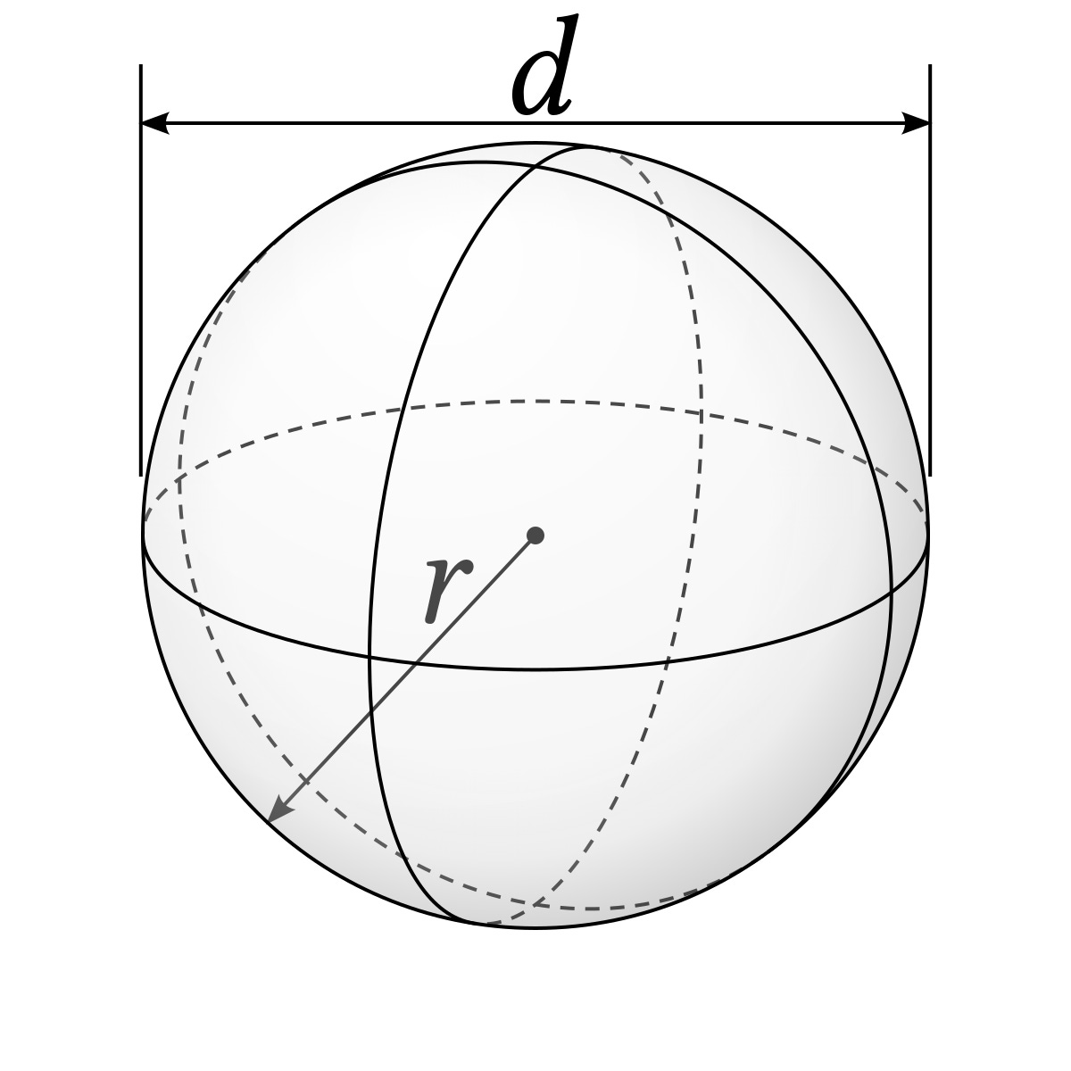](https://substackcdn.com/image/fetch/f_auto,q_auto:good,fl_progressive:steep/https%3A%2F%2Fsubstack-post-media.s3.amazonaws.com%2Fpublic%2Fimages%2F6ef49359-a8df-40ff-8315-a517cd6978c2_1200x1200.png)](https://substackcdn.com/image/fetch/f_auto,q_auto:good,fl_progressive:steep/https%3A%2F%2Fsubstack-post-media.s3.amazonaws.com%2Fpublic%2Fimages%2F6ef49359-a8df-40ff-8315-a517cd6978c2_1200x1200.png" \t "_blank)

https://freekahov.xyz/product\_details/16249161.html

Calculate pi. I ink there is a way to make pi rational, at least. If there is, we cna make it 3, though.

[[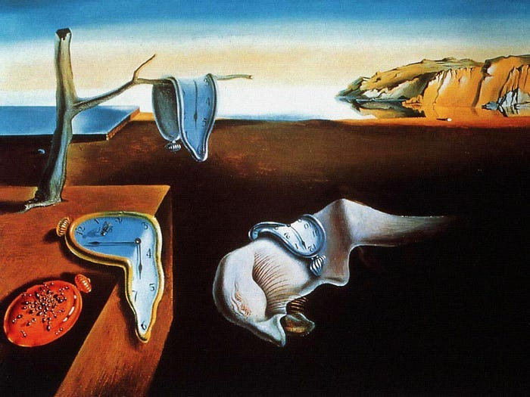](https://substackcdn.com/image/fetch/f_auto,q_auto:good,fl_progressive:steep/https%3A%2F%2Fsubstack-post-media.s3.amazonaws.com%2Fpublic%2Fimages%2Fa8962e7b-a19a-496e-a7e4-01ee9259c063_700x525.jpeg)](https://substackcdn.com/image/fetch/f_auto,q_auto:good,fl_progressive:steep/https%3A%2F%2Fsubstack-post-media.s3.amazonaws.com%2Fpublic%2Fimages%2Fa8962e7b-a19a-496e-a7e4-01ee9259c063_700x525.jpeg" \t "_blank)

“The Persistence of Memory,” Dali (Wikimedia Commons)

Jonathan Borwein’s “The Life of Pi: History and Computations” (2024) http://www.pi314.net/ref/pi-slides.pdf

LAST WEEK’s:

In 1997 the first occurrence of the sequence 0123456789 was found (late) in the decimal expansion of π starting at the 17, 387, 594, 880-th digit after the decimal point.” http://www.pi314.net/ref/pi-slides.pdf

](https://substackcdn.com/image/fetch/f_auto,q_auto:good,fl_progressive:steep/https%3A%2F%2Fsubstack-post-media.s3.amazonaws.com%2Fpublic%2Fimages%2F850adf4d-cfee-4349-9dfd-260ad8e4b2bb_529x494.png)](https://substackcdn.com/image/fetch/f_auto,q_auto:good,fl_progressive:steep/https%3A%2F%2Fsubstack-post-media.s3.amazonaws.com%2Fpublic%2Fimages%2F850adf4d-cfee-4349-9dfd-260ad8e4b2bb_529x494.png" \t "_blank)

Kanada’s Counts ([sdfsdfdsfdsfdsfd](http://www.pi314.net/ref/pi-slides.pdf))

“Prior to 1996, most folks thought if you want to determine the d-th digit of π, you had to generate the (order of) the entire first d digits. This is not true, at least for hex (base 16) or binary (base 2) digits of π. In 1996, P, Borwein, Plouffe, and Bailey found an algorithm for computing individual hex digits of π. “ http://www.pi314.net/ref/pi-slides.pdf

*π* is present in some structural engineering formulae, such as the [buckling](https://en.wikipedia.org/wiki/Buckling) formula derived by Euler, which gives the maximum axial load *F* that a long, slender column of length *L*, [modulus of elasticity](https://en.wikipedia.org/wiki/Modulus_of_elasticity) *E*, and [area moment of inertia](https://en.wikipedia.org/wiki/Area_moment_of_inertia) *I* can carry without buckling:[[200]](https://en.wikipedia.org/wiki/Pi#cite_note-203)

�=�2���2.

[[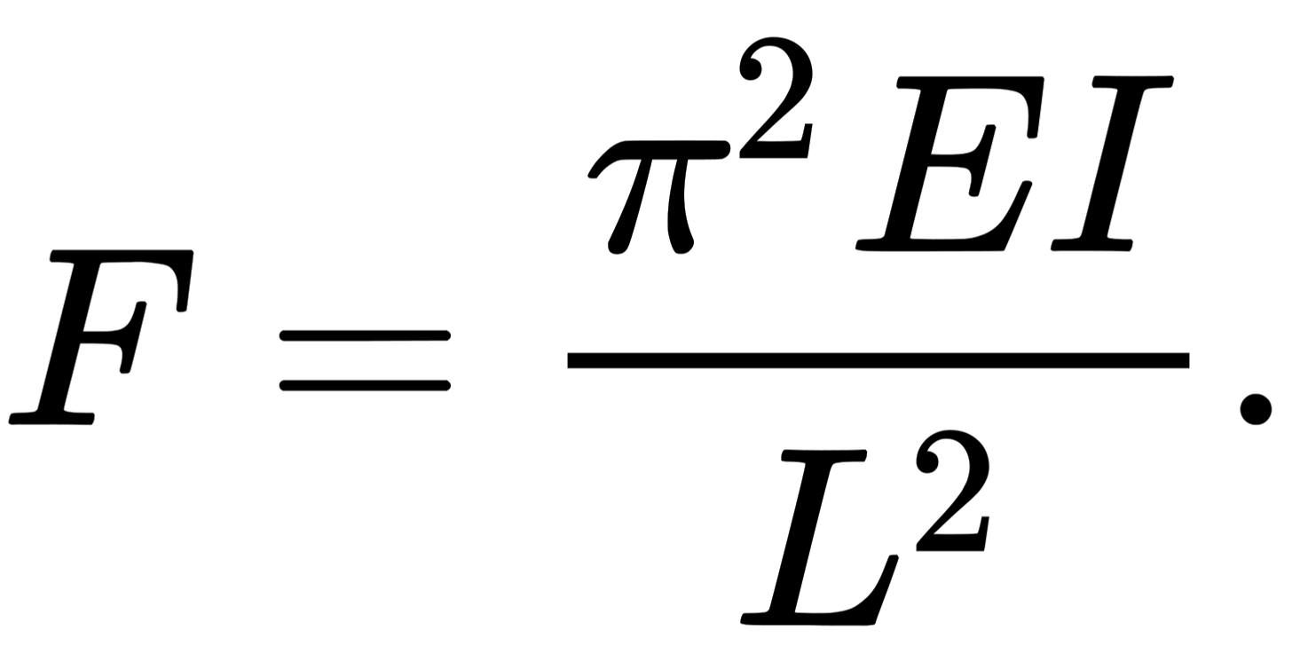](https://substackcdn.com/image/fetch/f_auto,q_auto:good,fl_progressive:steep/https%3A%2F%2Fsubstack-post-media.s3.amazonaws.com%2Fpublic%2Fimages%2F001212b1-2fdb-4f88-acfb-f55b6d029c0e_93x47.svg)](https://substackcdn.com/image/fetch/f_auto,q_auto:good,fl_progressive:steep/https%3A%2F%2Fsubstack-post-media.s3.amazonaws.com%2Fpublic%2Fimages%2F001212b1-2fdb-4f88-acfb-f55b6d029c0e_93x47.svg" \t "_blank)

The field of [fluid dynamics](https://en.wikipedia.org/wiki/Fluid_dynamics) contains *π* in [Stokes' law](https://en.wikipedia.org/wiki/Stokes%27_law), which approximates the [frictional force](https://en.wikipedia.org/wiki/Drag_force) *F* exerted on small, [spherical](https://en.wikipedia.org/wiki/Sphere) objects of radius *R*, moving with velocity *v* in a [fluid](https://en.wikipedia.org/wiki/Fluid) with [dynamic viscosity](https://en.wikipedia.org/wiki/Dynamic_viscosity) *η*:[[201]](https://en.wikipedia.org/wiki/Pi#cite_note-204)

�=6����.

[[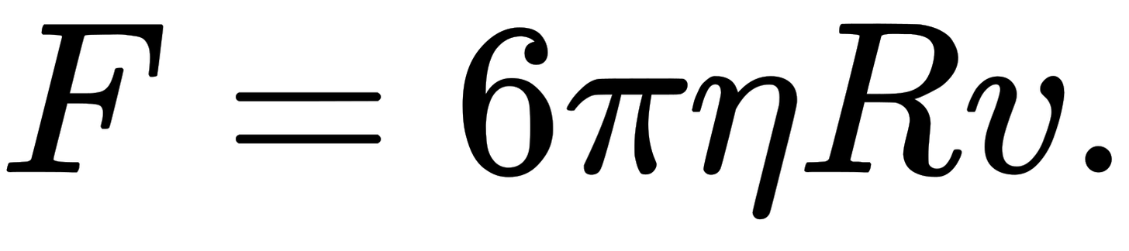](https://substackcdn.com/image/fetch/f_auto,q_auto:good,fl_progressive:steep/https%3A%2F%2Fsubstack-post-media.s3.amazonaws.com%2Fpublic%2Fimages%2F912d0e4f-786a-42bb-901f-40f0a5902b8d_96x21.svg)](https://substackcdn.com/image/fetch/f_auto,q_auto:good,fl_progressive:steep/https%3A%2F%2Fsubstack-post-media.s3.amazonaws.com%2Fpublic%2Fimages%2F912d0e4f-786a-42bb-901f-40f0a5902b8d_96x21.svg" \t "_blank)

�=��,where C is the circumference and d is the diameter of a circle

PICTURE

**NON-EUCLIDEAN SPACES**

But what I found today was how useful it is to point out that pi is NOT 3.14... if you measure a circle on a sphere . I showed them how the circle at the equator of a soccer ball would have a diameter on the surface much greater than a diameter on the circle cutting the middle.

I asked if pi would be bigger or smaller than 3.14, first. Smaller, Lyndon said, because the diameter in pi = C/D is bigger. So I asked if it would be bigger than 2, or less?

I drew a picture, as the first step in solving any problem, of a line with a semicircle above it. The line is the flat-circle diameter, which we call length 1, for convenience. The semicircle is the ball-circle diameter, the unknown we're trying to find.

I had them eyeball it and write their estimates on lapboards. 1.1, 2, 2.5 3, 2.5. Reasonable guesses, but almost all too big. I asked how to find it more accurately. "Use string" was the good scientific answer. I said they could do much better mathematically with info they had.

They were stumped. I said I'd give them a couple of minutes. I should have had them discuss it together too. Then Zoe suggested 3.14. "The right idea," I said, "but wrong." Eyeballing, 3 is too big.

They were still stumped. Then the light bulb went on. It's \*half\* a circle, not the whole circle. So what is it? Lyndon was first with his mental calculation--- 1.57. So it was less than 2 after all.

There were two things I didn't have time for. First, upper and lower bounds for the circle-on-a-ball pi by drawing a triangle inside the semicircle and a rectangle enclosing it. We'd need to use the Pythagorean Theorem for the triangle, I think, making it two right triangles.

Second, point out that pi-on-a-ball depends on which circle, unlike pi-on-a-flat-circle. If you have a small circle, pi gets bigger, approaching 3.14, because the diameter doesn't have as big a hump to go over (less curvature).

This was all inspired by a Tweet I read yesterday but didn't understand, something about how pi comes out differently when you use different metrics, all the way up to the taxicab metric, if I remember rightly.

The estimate 3.14 is much better, because it’s easy to memorize, pretty accurate, and crucially important to avoiding the fiasco of forgetting to buy a Pi Day present for your wife.

A better estimate of Pi than either the long one or 3.14 is simply to use Pi = 3. That’s pretty close, and its easier to remember.

So 3 is a pretty good estimate, and so is 3.14.

Sometimes you do need more digits. NASA uses 15 digits. That’s enough to get orbits within half an inch of their true value:

By cutting pi off at the 15th decimal point, we would calculate a circumference for that circle that is very slightly off. It turns out that our calculated circumference of the 30-billion-mile (48-billion-kilometer) diameter circle would be wrong by less than half an inch (about one centimeter). Think about that. We have a circle more than 94 billion miles (more than 150 billion kilometers) around, and our calculation of that distance would be off by no more than the width of your little finger. (The Jet Propulsion Lab’s Chief Engineer for Mission Operations and Science, [Marc Rayman](https://solarsystem.nasa.gov/people/2761/dr-marc-rayman/) in [“How Many Decimals of Pi Do We Really Need?**”**](https://www.jpl.nasa.gov/edu/news/2016/3/16/how-many-decimals-of-pi-do-we-really-need/) (2022))

But how do we come up with these values at all, even the value Pi = 3? You can eyeball it, but it’s hard to compare the length of a line (the diameter) with a curve (the circumference). There’s actually a way to prove it’s between 2 and 4 that I showed my 7th grade class, and it’s only a little bit harder to show it’s between 2 and 2√2. I've saved that for the end of this Substack, though, since even easy proofs will glaze many readers’ eyes. What I like to tell my students, though, is that there’s often both a scientific and a mathematical approach to finding the size of something. The scientific approach is to just measure it. So that’s their homework: measure Pi. So our scientific estimate is Pi = 3.04. This seems to be pretty similar across the ten circles, so we could conclude that Pi is the same for all circles, which is sort of true. [3](https://ericrasmusen.substack.com/publish/post/142425993?back=%2Fpublish%2Fposts%2Fdrafts#footnote-3)

#Feb. 26, 2024.A pi estimator

# Eric Rasmusen, erasmuse61@gmail.com, Python 3

#It would be nice to set it up so the precision is the time elapsed.

import time

import math

print(f"How many microseconds do you want the computer to use for each estimate? (e.g. 10, 20000)?")

microseconds = input()

microseconds = int(microseconds)

print("###################################### ")

print(f"The first method uses Leibniz's formula. ")

start = time.time()

pi = 4

for item in range(1,10000000000):

if item % 2 == 1: #This means if the remainder from item/2 is 1.

pi = pi - 4/(2\*item+1)

else: #If the remainder is NOT 1, then item is even.

pi = pi + 4/(2\*item+1)

end = time.time()

elapsed = 100000\*(end-start)#To measure in microseconds

# print(f"Computer time used was {elapsed:0.2f} microseconds.")

if elapsed >microseconds:

break

# print(f"Item is {item} and pi is {pi:0.2f}")

print(f"Pi = {pi:0.15f} using Leibniz.")

print(f"CPU time: { elapsed:0.2f} microseconds.")

print("###################################### ")

print(f"The second method is Pfouffe's series. ")

start = time.time()

pi = -3

for item in range(1,100000000000):

pi = pi + item\*2\*\*item\*(math.factorial(item))\*\*2/math.factorial(2\*item)

# print(f"Iteration {item}: pi is {pi:0.2f}.")

end = time.time()

elapsed = 100000\*(end-start)#To measure in microseconds

# print(f"Computer time used was {elapsed:0.2f} microseconds.")

if elapsed > microseconds:

break

print(f"Pi = {pi:0.15f} using Pfouffe.")

print(f"CPU time: {elapsed:0.2f} microseconds.")

print("###################################### ")

print(f"That is all.")

print("###################################### ")

#I erased the normal distirbution method by accident.

#It was fun, but I didn't need to do an approx of an integral

#Maybe for fun I will try it later.

Your output should look something like this:

How many microseconds do you want the computer to use for each estimate? (e.g. 10, 20000)?

16

######################################

The first method uses Leibniz's formula.

Pi = 3.146243791226152 using Leibniz.

CPU time: 16.09 microseconds.

######################################

The second method is Pfouffe's series.

Pi = 3.141592653471791 using Pfouffe.

CPU time: 16.12 microseconds.

######################################

That is all.

######################################

From [the World Of Pi website](http://www.pi314.net/eng/histoire.php)

](https://substackcdn.com/image/fetch/f_auto,q_auto:good,fl_progressive:steep/https%3A%2F%2Fsubstack-post-media.s3.amazonaws.com%2Fpublic%2Fimages%2Fbbdfaa1e-1a0a-45c7-847c-7fc21d568e87_1149x606.png)](https://substackcdn.com/image/fetch/f_auto,q_auto:good,fl_progressive:steep/https%3A%2F%2Fsubstack-post-media.s3.amazonaws.com%2Fpublic%2Fimages%2Fbbdfaa1e-1a0a-45c7-847c-7fc21d568e87_1149x606.png" \t "_blank)

·

�=��(where C is the circumference and d is the diameter of a circle)

�=��(−1)�

**Formulas, with commentary**

I do show them a couple pages of fancy formulas for Pi- Ploufe's, Euler, Newton, etc. -- even though they can't understand most of them. Leibniz's, they can--- Pi = 4( 1 - 1/3+1/5- 1/7 +... .

. Add EUler Identity. Some trig ones.

Do an explanation of the Plourffe’s and the Normal equations, as i did for the students.

On the Normal: “There is a story about two friends… From the start of Wigner’s essay. “The Unreasonable Effectiveness of Mathematics in the Natural Sciences”. Cite Euler Substcak too.

Mathematicians like finding different proofs of the same theorem for this reason. To really understand the number Pi, you need to understand all the different equations that describe it.[7](https://ericrasmusen.substack.com/p/why-does-2-3-6#footnote-7-142240442)

�=4(1−13+15−17+19−⋯)(Leibniz′s formula for �)

�=∑�=1∞�2��!2(2�)!−3(Plouffe′s series)

�=12(∫−∞∞�−�2/2��)2 (from the Normal density)

������ ������������ ���� ��� ��. ��������ℎ �0:=23: ��� �0:=3.����������������� ���������, �����������������

Peter Borwein, [The World of Pi](http://www.pi314.net/eng/borwein.php) website.

[1](https://ericrasmusen.substack.com/publish/post/142425993?back=%2Fpublish%2Fposts%2Fdrafts#footnote-anchor-1)

How interesting that “value'“ and ‘irrational” have so many different meaning! (so many values?) Even “irrational values” has a couple.

[2](https://ericrasmusen.substack.com/publish/post/142425993?back=%2Fpublish%2Fposts%2Fdrafts#footnote-anchor-2)

In my fraternity back in the 1960s we probably had the world champion memorizer of Pi digits, Bruce Dan. He had memorized over 500 digits; alas there was no official record back then.

But 30-odd years later we had a reprise at my home where we all pledged X dollars to our pre-DEI Alma Mater for each digit he could still do, which turned out to be about 144. This event was memorialized here, with the actual recitation of digits starting at about 9:45.

[personal communication, 2024]

[3](https://ericrasmusen.substack.com/publish/post/142425993?back=%2Fpublish%2Fposts%2Fdrafts#footnote-anchor-3)

“Pi is the same for all circles, which is sort of true.” I am sure some readers are saying “What! It’s not just sort of true, it’s ALWAYS true, if you could measure exactly and it is an exact circle.” Well, no. You’re forgetting about non-Euclidean spaces. “Well, that’s being picky,” you will say. “That’s extremely abstruse, and you can’t expect your 7th graders to think about that.” But I can! Continue reading this Substack.

View draft history

Settings