Eric Rasmusen,
erasmuse61@gmail.com
December 19, 2022

How to Make a Christmas Card

Send out Christmas cards, preferably by snailmail, not email, and around December 1 of each year. Christmas cards a way to show you are thinking of someone and would like them to know it. They are a way of discovering whether the other person cares about you (highly imperfect of course, since most people wouldn’t reply to a letter even from their beloved mother, and a few don’t even reply to the Internal Revenue Service). They are a way to tell people what is happening with you when they don’t know or might not know. This is especially useful if you’ve moved or someone in your family has gotten married or died-- especially if they died an untimely death. All these reasons apply even if you do not believe Jesus was born in Bethlehem; you are not endorsing Christianity merely by sending a Christmas card, only acknowledging that it is a holiday. That is true even if you say “Merry Christmas”, just as saying “Happy Hanukah” does not give you the right to citizenship in Israel. To be sure, the holiday has a different meaning for Christians, but the pictures and words in your card can convey all the nuances needed. For real, believing, Christians, there is an extra reason to send cards: they are a very easy way to remind people of the deep meaning of Christmas and an invitation for them to inquire if they want to know more.

The ideal is to send paper cards by snailmail because it is a greater compliment the recipient and will please them more. It is more special, and a more pleasant surprise. But sending by email is much much better than nothing. Sending around December 1 is the best time because Christmas should not start immediately after Thanksgiving but sending cards at the start of the Christmas season allows the recipient time to first think of the idea of sending out cards, then to think how to do it, then to procrastinate, and finally to send the cards out by Christmas Day.

You may also be interested in my 12 Days of Christmas document, for activities to do on the 12 days starting with Christmas Day that are a holiday for so many people, especially children. See https://rasmusen.org/special/christmas/12days/12days.of.Christmas.pdf.

Now that you’re motivated, here’s how to do it:

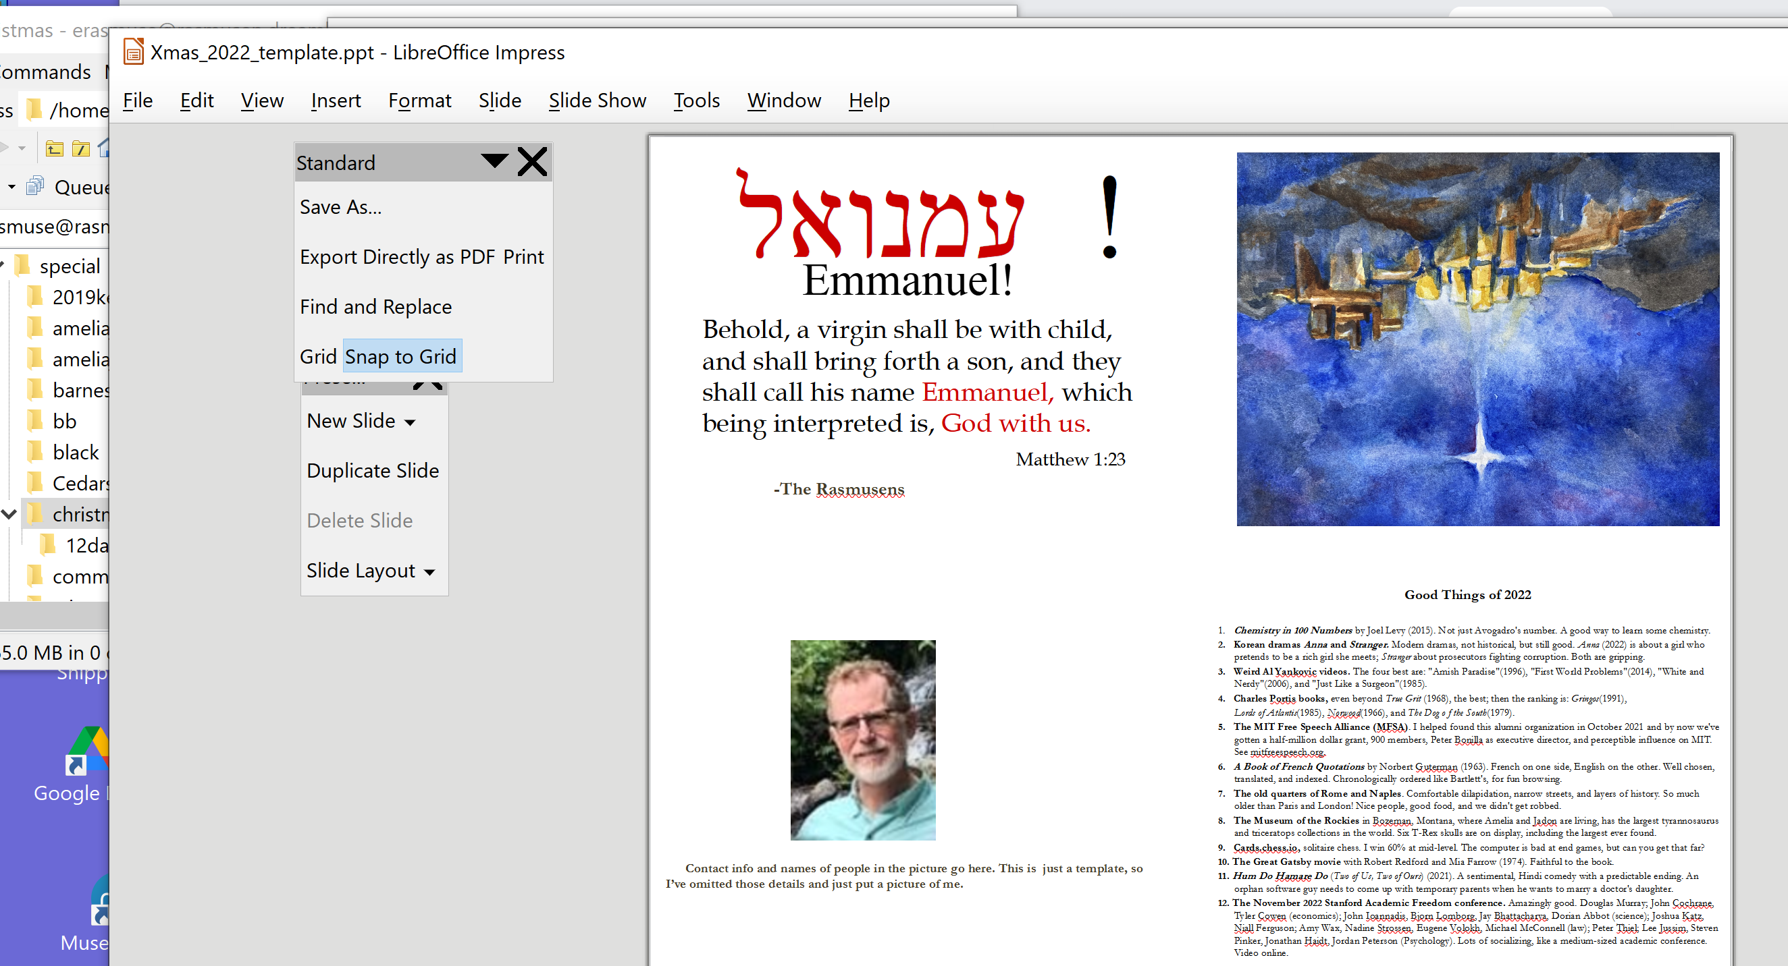
1. Start by downloading my 2022 Christmas card as an example. Save it to somewhere on your computer where you can find it again, when it asks you where to save it to. It is up on the web at https://rasmusen.org/special/christmas/Xmas2022_Template.ppt

2. You need a Slides app to open up a powerpoint file, the kind with *.ppt at the end of its name. You can try double-clicking on the file you downloaded, and if you already have Microsoft-Powerpoint, the file will open up in it and you can work on it. Or, maybe you have some other app installed that will do it. You can’t use a wordprocessing app such as Microsoft Word or Wordpad.
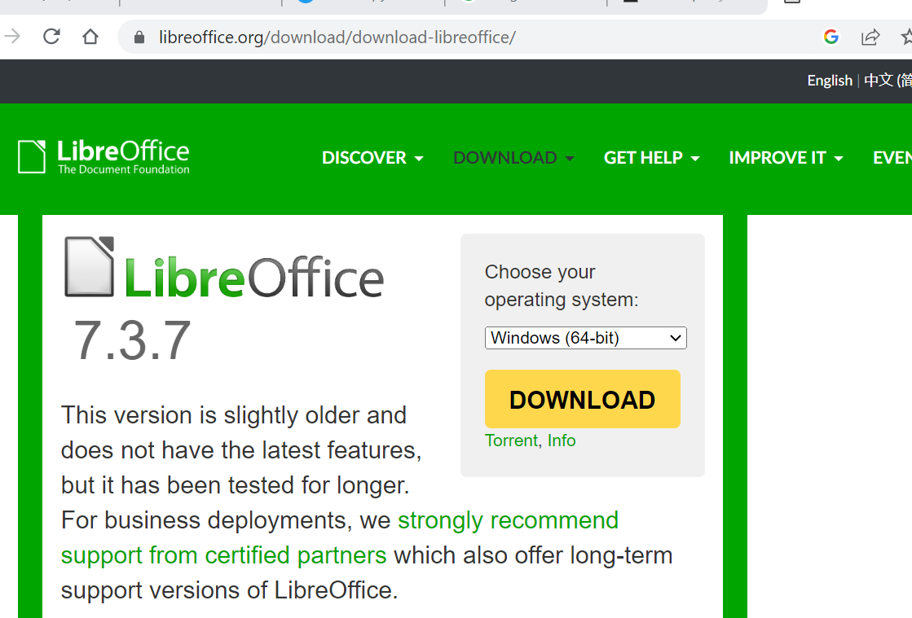
If you don’t already have Powerpoint, it’s easy to download and install a free version, LibreOffice. In fact, I have Powerpoint but I’ve decided I actually prefer LibreOffice. Go to https://www.libreoffice.org/download/download-libreoffice/ .
Then right click on the operating systems menu and choose your operating system. You probably have Windows (64-bit) or MacOS (Intel). Press the download button and install the app, following its instructions.

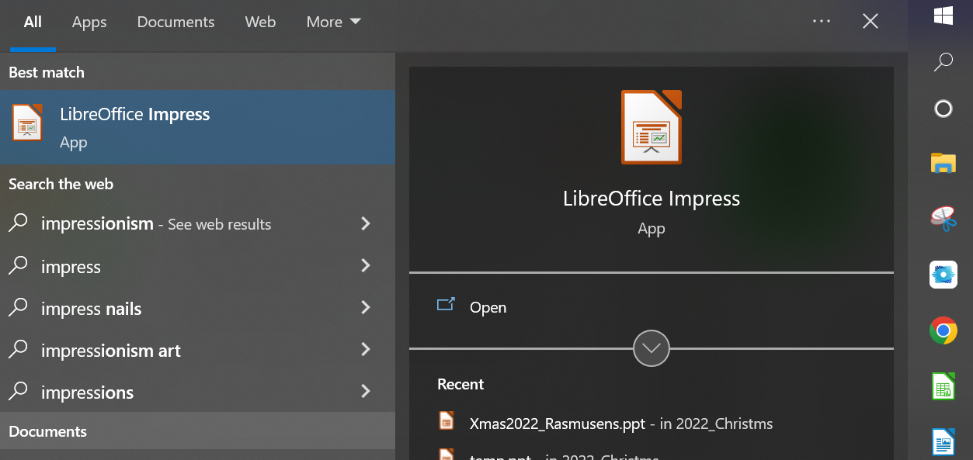
3. Now open LibreOffice Impress. If you have Windows, you can do that by first clicking on the strange-looking Windows symbol and then typing, Impress.

4. Once you have the app working, you can open the file Xmas2022_Rasmusens.ppt from whatever directory you put it in. Once you have Impress opened up, go to the FILE menu at the top, click it, and choose Open from the menu. The computer will ask you to find the file you want to open, so go and find it and open it.

5. Once it is open, save it under a different name, such as Smithfile22.ppt. Use the FILE menu and then SAVE AS to do this. This way, you can change the file and you will still have the original available to go back to if you want to .

6. Now you are ready to modify the file. It is one page, in four equal parts that we will call Emmanuel, People, Star, and Best Things. To make this your personal card, you can change any or all of these. First, though, print it out in black and white (to save money) to try folding it. Under FILE, find the command PRINT and print it. Then fold it sideways first, so Emmanuel and People are on one side, and Star and Best Things on the other. Lastly, fold it again. At the end, Star will be on the front, Best Things on the back.

You can use any kind of paper you like. I advise stiff white high-quality paper, but not cardstock, though cardstock will work too, and so will flimsy paper. You do not need to glue or tape the card together at the end, but you can try that if you want. You do not need to use double-sided printing.
Next, go back and personalize the four sides. Here are their purposes and what you can do with them.

7. Star. This is the front page. It is upside down on the slide page. That is so the folding comes out right. I like to have a picture there, which we change every year. We always use a picture some child in the family drew. Sometimes it is artistic like this one, sometimes it something a three-year-old drew. It is always about the Christmas Story.

First, draw your picture, or find it somewhere. If you drew it, it is on paper, so you need to take a photo of it. Do that in natural sunlight and make sure your camera doesn’t leave a shadow on it. Then send the photo file by email to your computer. Once it is on your computer, click on it to open it up. Then use a screencapture app like the standard Windows Snip app to copy it.

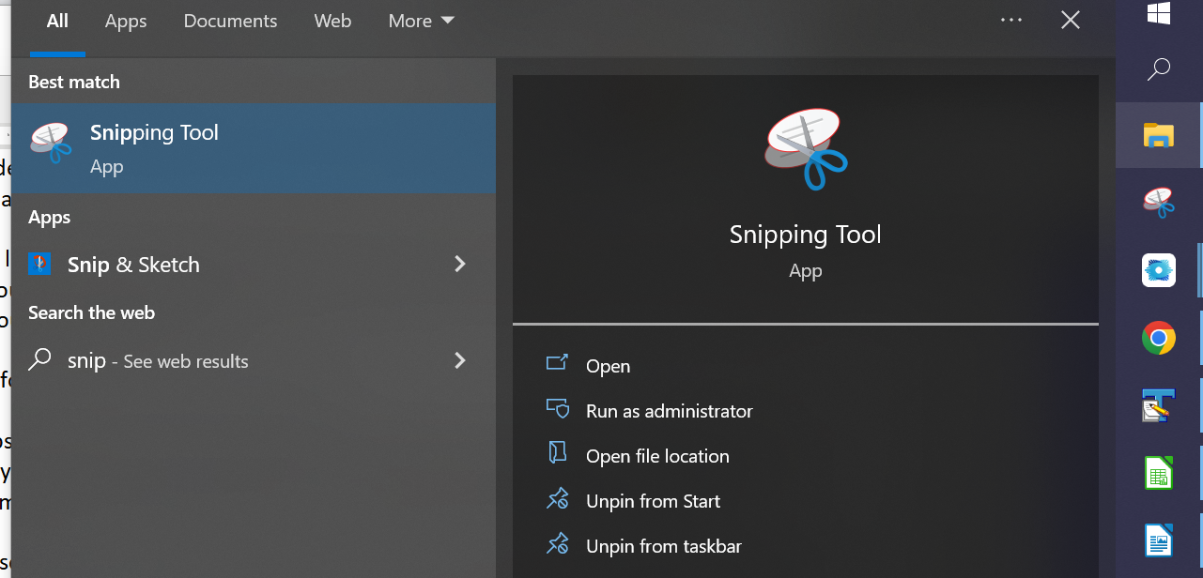
While you have your photo file opened up, click on the snipping tool app to open it. Then click on NEW. The screen will get a little cloudy. Then draw a box around the part of the picture you want to put in your slide file and hit return, and it will do a screen shot of that part of the picture.

Go to your slide file now, and type CTRL-V, and the screen shot will paste into the file.

Once it is in the file, you can resize it and move it whichever part of the page you want to put it in. I find I need to finish this in a hurry, so I won’t explain how to do that.

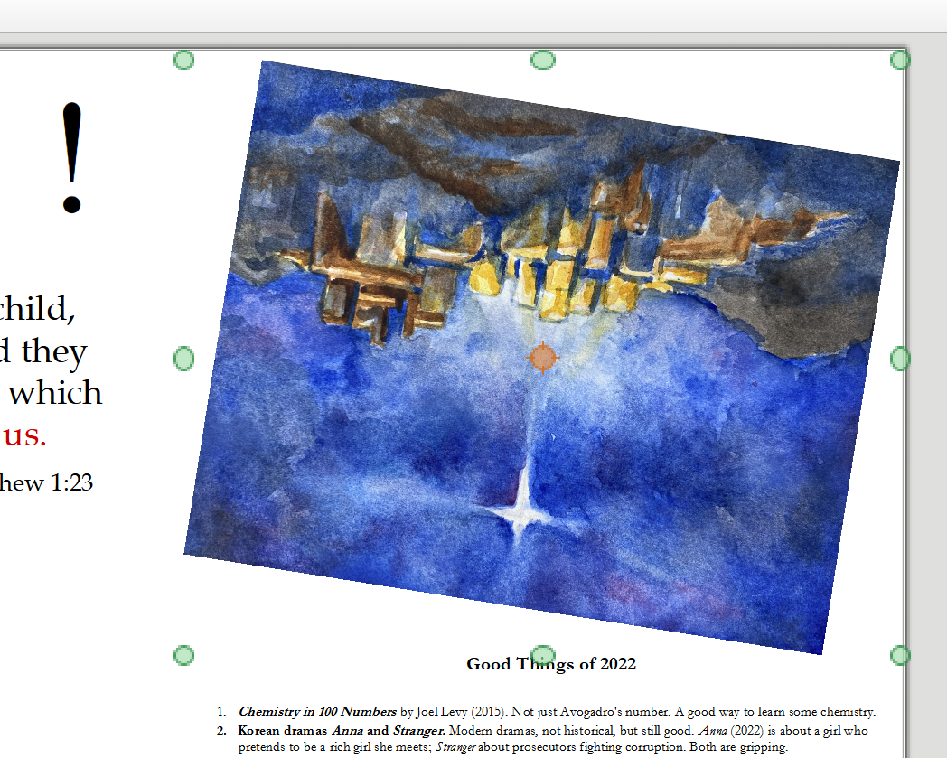
The hardest part is to rotate the picture so it is upside down, which you want for this quarter of the page and this quarter alone. Put your cursor over the picture you want to rotate and click. This will cause the cursor to turn into a four-arrow symbol, and 6 filled-in disks will appear around the picture. Go to the FORMAT menu and choose ROTATE. Then go back to the picture and click the cursor over a corner of the picture, and instead of a filled-in disk, you will see an arrow going around in a circle. Keep the mouse clicked down and you can draw that corner around to rotate the picture. (It is possible to use a Portrait layout to make a card two, in which case two of the quarters will have to be upside down-- see https://rasmusen.org/special/christmas/Xmas2021_Template.ppt for an example.)

(8) Good Things page. This is the back page. You can leave it blank. If it is blank, you can handwrite messages on it. Or, you can put your own Good Things of 2022, or a family newsletter.

(9) Emmanuel page. This is the first inside page. I have put a Bible verse there with the Hebrew for “Emmanuel”, and “Merry Christmas”. On cards to print out on paper, we usually delete the “Merry Christmas” and write it in by hand instead, to provide a more personal touch.

(10) People page. This is the second inside page. We put a picture of our entire family including our son-in-law, a group portrait if we can, but in recent years with floating heads for people living far from home. We include the names, for friends and relatives who don’t know or might have forgotten everyone’s names. We also include contact information, so the recipient can send us a card back after they’ve accidentally thrown away the envelope, and add a phone number and emails for good measure.

(11) Now, Export as PDF. (Do not choose Export Directly as PDF.) A window of choices will come up. Choose Lossless Compression (not 90% or anything else). This will result in a big pdf file. A big pdf file is not as good for sending by email or text, but it is better for printing to paper. If you want a smaller file, click 90% compression and 300 dpi. That will still look fine on a computer screen. The *.ppt file is 5,000K in size, the uncompressed *.pdf is 7,000K, and the compressed *.pdf is 700K.

(12) Test your pdf by printing it in black and white on cheap paper. Fold it after it prints and see if it looks good. Go back and edit the ppt file if necessary. It probably will be necessary, because it’s hard to get the centering and spacing right so that the card looks nice after it folds.

(13) Put the pdf file on a USB flashdrive and take it to a copyshop to be printed in color. I used 32 lb paper at Office Depot. The reasons you converted the ppt to pdf rather than printing directly are (a) so the copyshop could easily print it, and (b) so if you email to someone they can view it on their computer even if they don’t have Powerpoint. Then, put them in envelopes and mail them out, or put in envelopes and hand out to local people. Keep a few with you in purse or jacket during the Christmas season to give out to people as you meet them. Also, I email the pdf to some people, including those living abroad if I don’t get round to mailing the cards early enough.

