May 24, 2021
941 words, including front and end matter.

Note: Do not read this unless you are willing to keep it out of the public eye. You may talk privately about it, but neither IU nor I wants this to go public yet. Ask me if you want to know when it can be written about. If anyone willfully publishes it before I give the OK, it may cause me considerable money damages. This is not an op-ed. It is a summary for people who are interested, particularly those in a position to write on it later themselves or to take action.

Indiana’s Lack of Due Process in Investigating Professors for Their Speech: The University versus The Individual

Professor Eric Rasmusen of Indiana University-Bloomington’s Kelley School of Business was attacked in 2019 by the half-million-member Twitter bad-boyfriend-story account SheRatesDogs. He was “cancelled” for tweeting a quote about genius personality traits that suggested women are less likely than men to have the traits, some desirable, some more dubious, to excel as scientists. Provost Lauren Robel and Kelley Dean Idalene Kesner denounced him publicly, calling him—among other thing--- reprehensible, sexist, racist, homophobic, intolerant, 18th-century, vile, stupid, bigoted, and loathsome. While grudgingly admitting that a professor’s speech is protected by the First Amendment and that nobody had ever complained about Rasmusen discriminating against them in his 20+ years at Indiana, they issued a call for informants to come forward with accusations. The University then commenced a Title IX investigation that judged him guilty of discrimination and punished him with numerous humiliating restrictions.

The year-long Title IX investigation determined that Professor Rasmusen had not engaged in sexual harassment or discrimination. Rather, the University concluded he had made “unwelcome comments based on race, sex, sexual orientation, and religion” in class, hallways, and Twitter. Rasmusen’s supposed offenses included asking foreign students to answer questions about their home countries and complimenting female professors on their attire. He was condemned for using the generic pronoun “he” instead of “he or she” on his course syllabus, something the University labels a “term of violence”. Before any evidence was collected, the University moved him to an isolated office and required him to use blind grading, even though imposing penalties in advance of evidence is illegal. At the end of the process, it banned him from participating in recruiting new faculty and required all his classes to be videotaped so he would be under constant surveillance.

The attack continued. When Rasmusen received the 44-page Title IX report after a year of work by five attorneys from the “Office of Institutional Equity,” he was given a mere ten days to respond. He emailed the students in his last three classes to ask if they wanted to comment, and whether they’d been quoted correctly if they happened to be one of the 20 or so anonymous witnesses. For this, the University charged he had “used university property for personal gain,” “violated confidentiality”, and “retaliated against witnesses”. The University’s position is that neither accusers nor accused can contact possible witnesses or mention the existence of an investigation except “to appropriate university officials and law enforcement”. For trying to collect evidence with which to defend himself, Rasmusen went through three days of zoom hearings before the Faculty Misconduct Review Committee. It ruled that repeating what anonymous witnesses had said was “inherently retaliatory as it has the potential to traumatize witnesses” even if they were anonymous and had already graduated from college. They recommended a 10% pay cut, in effect a fine of $23,000 per year for the rest of his career.

Rasmusen is 62 years old, a graduate of Yale and MIT who has held positions at Harvard and Yale law schools as well as the economics departments of Harvard, Oxford, and the University of Tokyo. Well-known for Games and Information, a book on mathematical modelling that has been translated into Japanese, Chinese, Spanish, Italian, and French, he is better able to fend off personal attacks than younger professors whose reputations are still being formed. Younger scholars and students, however, have their careers to think about and can’t afford to offend the administration. The chilling effect on open discussions and academic discourse is devastating to Indiana University, whose administration is clearly willing to make full use of the imbalance of power between its army of state-funded bureaucrats and lawyers and the lonely individual who dares to criticize.

What is to be done? Indiana State Representative Jack Jordan’s newly passed law to require state universities to survey students on free speech incidents and publish reports on free speech is a move in the right direction. Even better would be the establishment of a Free Speech Office to counterbalance the Office of Institutional Equity, which is in effect an Office of Administrative Repression. Both offices should be required to adhere to principles of due process and transparency rather than operate as secret tribunals willing to frame the innocent. Especially important--- and easy to implement--- would be a state ban on the use of nondisparagement clauses by universities to hush up people who sue them for malfeasance. Sunlight is the best disinfectant--- and there is a lot to disinfect in the Provost’s office.

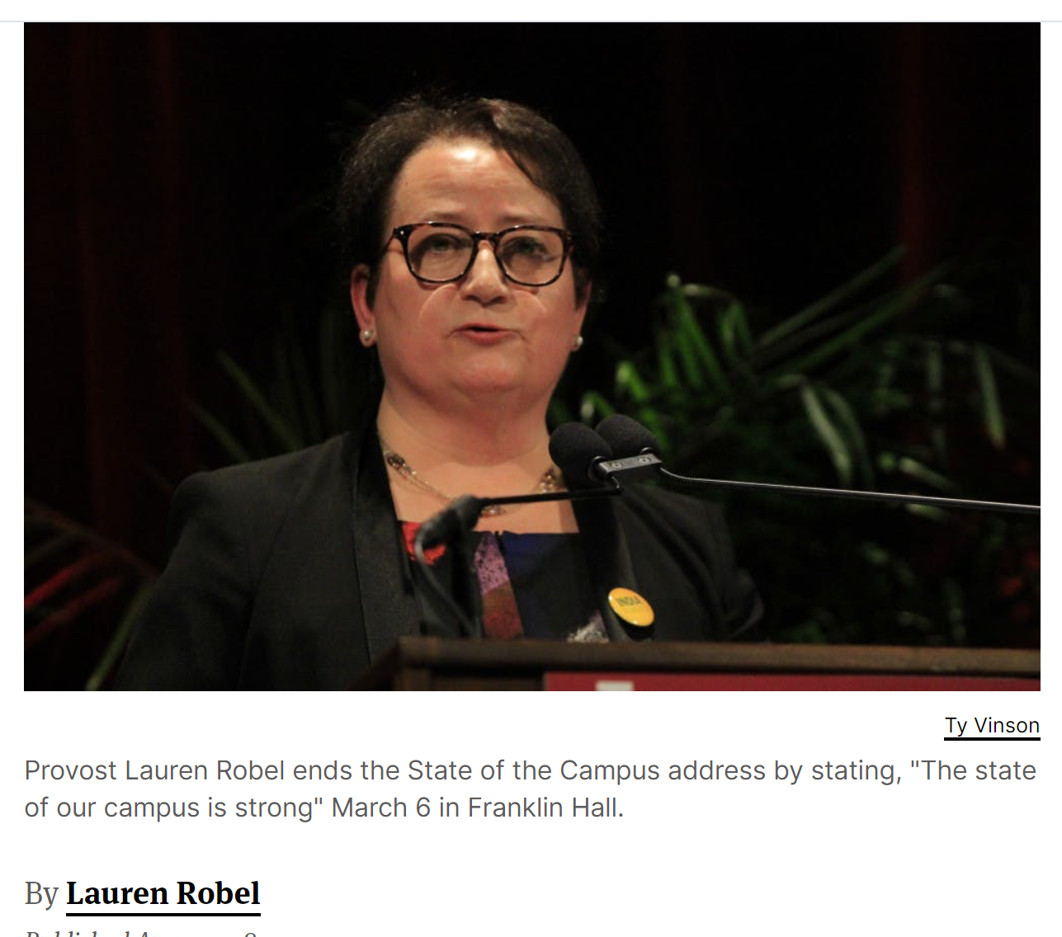
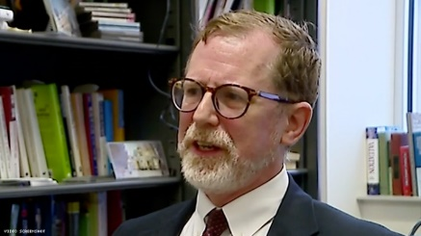
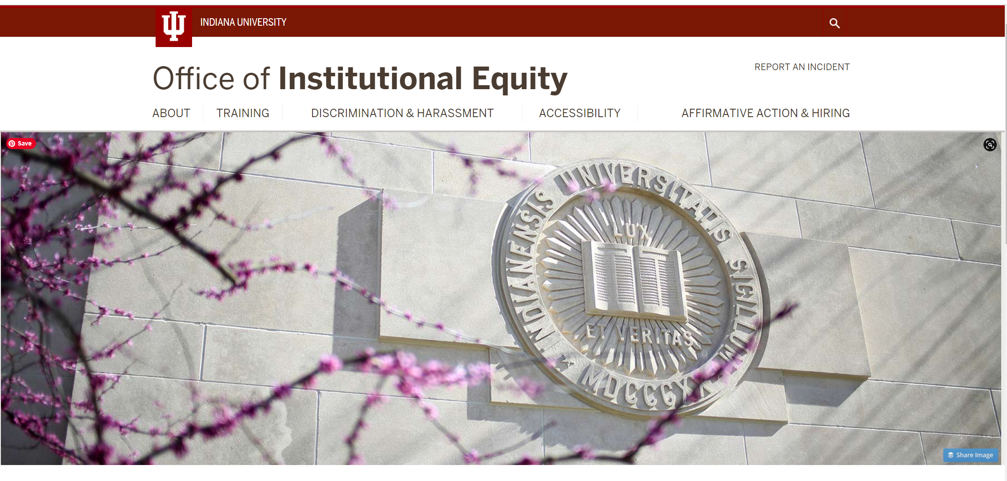

Next steps: VP Applegate will make a decision based on the Faculty Misconduct Committee’s recommendation. He can make the punishment bigger if he wishes. Then Rasmusen can appeal to the Faculty Board of Review. That could take a month or so. He was earlier granted a sabbatical for 2021-2022, a research leave on half-pay, which he can spend in Bloomington or elsewhere, so whatever happens, he will not be teaching classes this coming year.

